Development and evaluation of meropenem encapsulated nanostructured lipid carriers as an antimicrobial treatment of Pseudomonas aeruginosa in cystic fibrosis

By

**Dr Ali Ahmad**

Submitted in partial fulfilment of the Master of Science (MSc.), School of Pharmacy and Biomedical Science, University of Lancashire

**Date of submission**: 3 August,2025



**Acknowledgements**

I would like to express my sincere gratitude to my supervisor **Professor Kamalinder Singh** for her invaluable guidance, consistent support, and continuous encouragement throughout the course of my research. Her mentorship has significantly enriched my scientific and academic journey.

I would also like to extend my heartfelt appreciation to**Dr. James Millar**for his expert insights, constructive feedback, and unwavering support, which have greatly contributed to the depth and clarity of my research.

I am also deeply thankful to **Deepshikha** for her sincere support and guidance during this project.

Finally, I extend my heartfelt appreciation to my wife **Dr. Maria Murad** for her unwavering support, patience, and encouragement throughout this endeavour. Her steadfast belief in me has been a constant source of motivation.

Abstract

Cystic fibrosis is an autosomal recessive disease characterized by chronic respiratory infections, with P. aeruginosa being the predominant pathogen. The persistence of P. aeruginosa infections in cystic fibrosis patients is attributed to several factors, including intrinsic and acquired resistance mechanisms to antibiotics, reduced antibiotic penetration due to thick mucus, and an altered pulmonary microenvironment. Meropenem, a carbapenem antibiotic, is considered as a first-line therapy for P. aeruginosa infections. However, its therapeutic efficacy is often compromised by bacterial resistance, and its limited diffusion through mucus. This study investigates the potential of meropenem-loaded nanostructured lipid carriers (MPM-NLCs) and meropenem- and thyme oil–co-loaded nanostructured lipid carriers (MpM-TO-NLCs) as a drug delivery system to improve antibiotic permeability and treatment efficacy against P. aeruginosa.frmulations comprising blank NLCs, MPM-NLCs and MPM-TO-NLCs were prepared using hot homogenization followed by probe sonication. The physiochemical characteristics, including particle size (PS), zeta potential (ZP), and polydispersity index (PDI) were analysed using Dynamic light scattering (ZetaSizer Advance). Encapsulation efficiency (%EE) of meropenem was quantified using a validated high-performance liquid chromatography (HPLC) method.

**KEY WORDS**: Cystic fibrosis, respiratory infections, nanostructured lipid carriers, meropenem, therapeutic efficacy, hot homogenization, probing sonication, HPLC.

**Chapter 1: Introduction**

* 1. **Introduction to Cystic Fibrosis**

Cystic fibrosis is an autosomal recessive disease, caused by mutations in the transmembrane conductance regulator (CFTR) gene on chromosome 7 (Döring et al., 2000). The gene encodes the CFTR protein which is an ion transporter (Cabrini et al., 2022) that regulates chloride and sodium ion transport across epithelial membranes the lung, pancreas, intestines (Brown, White and Tobin, 2017) (figure 1.1). CFTR protein is an ion channel responsible for chloride ion (Cl⁻) transport across epithelial membranes. The protein comprises two membrane-spanning domains, each forming six transmembrane helices that create the chloride channel pore It also contains two nucleotide-binding domains (NBD-1 and NBD-2) which hydrolyse ATP to regulate channel gating (Figure 1). The regulatory (R) domain located between the NBDs modulates channel activity through phosphorylation. Dysfunctional CFTR, due to genetic mutations, impairs chloride transport and leads to the pathophysiology observed in cystic fibrosis (Lyczak, Cannon and Pier, 2002). The protein transports chloride **(Cl⁻) ions**out of epithelial cells into the lumen and inhibits adjacent Epithelial Sodium Channel (ENaC) (Gentzsch et al., 2010) (Figure 1). Epithelial Sodium Channel (ENaC) promotes the absorption of sodium ions (Na⁺) and water from airway surface liquid (ASL) into epithelial cells. In cystic fibrosis, inhibition on Epithelial Sodium Channel is demolished due to dysfunctional or absent CFTR protein and the resultant airway surface liquid (ASL) dehydration (Boucher, 2007; Hill et al., 2018) leads to a depletion of the periciliary liquid layer (PCL) and a viscous mucus. This impairs the mucociliary clearance mechanism (MCC), resulting in the accumulation of mucus and colonization by Haemophilus influenza, Pseudomonas aeruginosa (Boukadida et al., 1993; Qin et al., 2022; Sainz-Mejías et al., 2020).) and Staphylococcus aureus (Xu et al., 2024; Stogios and Savchenko, 2020), and methicillin-resistant Staphylococcus aureus (MRSA) (Akil and Muhlebach, 2018). Furthermore, the resultant ionic imbalance alters the chemistry of the airway surface liquid (ASL), creating an acidic environment (Birket et al., 2018) that diminishes or inactivates natural defence molecules of the respiratory tract such as defensins, lysozymes, and lactoferrins, thereby making bacterial eradication even more challenging (Berkebile and McCray Jr, 2014). Hence, both mechanical and chemical defences are compromised, explaining why CF patients suffer from chronic airway infections and inflammation (Cabrini et al., 2022).

. 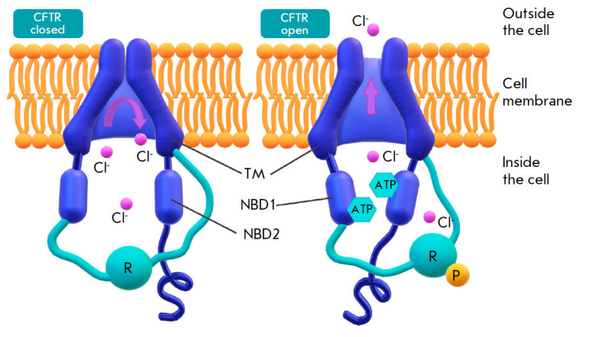

Figure 1.1: Illustration of the CFTR structure (Lomunova and Gershovich, 2023).

Recurrent infections with Haemophilus influenzae during childhood and Staphylococcus aureus in early life are progressively replaced in adulthood by recurrent and chronic infections with Pseudomonas aeruginosa (Lyczak, Cannon and Pier, 2002) . The immune defences in CF are inefficient at clearing bacterial infections and instead trigger an exaggerated inflammatory response, marked by infiltration of neutrophils into the airway lumen. The combination of chronic infections with inflammation causes progressive damage to the bronchial wall, airway remodelling, and obstruction, ultimately leading to severe respiratory insufficiency.

In the digestive system, viscous mucus obstructs the pancreatic ducts, thereby impeding the enzymes from reaching the small intestine. This compromises the absorption of nutrients and fat-soluble vitamins, resulting in malnutrition, stunted growth and chronic digestive problems. In normal sweat glands, the cystic fibrosis transmembrane conductance regulator (CFTR) promotes the reabsorption of chloride ions from the primary sweat as it passes through the ductal epithelium (figure 1.2). This creates electrochemical gradient that facilitates the passive influx of sodium ions via the epithelial sodium channel (ENaC), followed by the osmotic movement of water. In cystic fibrosis, this coordinated reabsorption mechanism is disrupted, leading to the excretion of sweat with abnormally high concentrations of sodium and chloride with a fluid loss from the body (Wine, 2022). This manifests clinically as hypertonic (salty) skin and hyponatraemic dehydration, particularly under conditions of excessive perspiration.

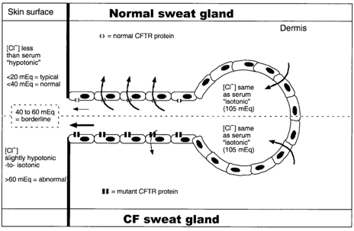

Figure 1.2: Schematic illustration of CFTR in Sweat Gland (Lyczak, Cannon and Pier, 2002).

A sweat chloride concentration exceeding 60 mmol/L, confirmed on two or more occasions using quantitative pilocarpine iontophoresis, remains the gold standard for the diagnosis of cystic fibrosis (DeMarco, Dietzen and Brown, 2014).

Cystic fibrosis is a genetically heterogeneous disease. Approximately 350 out of 2,000 identified variants of the CFTR gene have been confirmed to be pathogenic (Sharma et al., 2021). These mutations are classified into **six categories** based on their effects on the synthesis, function, or stability of the CFTR protein, with each class contributing differently to disease severity and clinical phenotype (Elborn and Vallieres, 2014). **Class I mutations**are nonsense mutations, resulting in truncated, unstable mRNA and complete absence of CFTR protein. These mutations result in the most severe phenotypes due to complete loss of CFTR function. **Class II mutations**, the most prevalent mutations in the gene, include Gly85Glu, Arg560Thr, Ile507del, Asn1303Lys and ΔF508 mutations. This mutation involves three-base pair deletion, resulting in the misfolding of the CFTR protein. Consequently, the misfolded protein is retained within the endoplasmic reticulum and degraded, preventing its trafficking to the plasma membrane (Boucher, 2003). ΔF508 mutation has the highest prevalence in this category (Ren et al., 2018; De Boeck et al., 2014). **Class III mutations**, such as Gly551Asp, affect CFTR gating. Although the protein reaches the membrane, defective channel opening reduces chloride ion transport. **Class IV mutations** such as Arg117His and Arg347Pro produce CFTR proteins with impaired chloride conductance, leading to inefficient ion transport even if the channel is open. This often correlates with milder clinical manifestations compared to classes I–III.

**1.1.2. Current Therapeutic Methodologies for Cystic Fibrosis**

Treatments for CF include **symptomatic management and CFTR-modulating therapy.** Traditional therapies for cystic fibrosis (CF) have focused on symptom relief rather than targeting the fundamental molecular defect. Such therapies include: m**ucolytics, bronchodilators, anti-inflammatory agents, antibiotics**for respiratory infections and nutritional support (Elborn and Vallieres, 2014b). While effective for symptomatic relief, these approaches do not address the underlying molecular defect.

With advances in molecular biology and an improved understanding of the genetic basis of cystic fibrosis, the focus of treatment has shifted toward CFTR-modulating therapies that aim at restoring the function of CFTR protein. These therapies are categorized into: potentiator (modulator) drugs, corrector molecules, and gene therapy. **Potentiators** like ivacaftor enhance the function of CFTR channels that reach the cell surface but have impaired gating (class III mutations). They increase CFTR channel open probability, improving chloride transport and lung function. **Corrector therapy** such as **Lumacaftor**and **tezacaftor**(**VX-661)** addresses misfolded CFTR proteins and improve its trafficking to the cell surface. **Readthrough therapy** aims at overcoming premature stop codons (class I mutations). In normal protein synthesis, stop codons (UGA, UAA, UAG) signal the ribosome to terminate translation. Incorporating a near-cognate tRNA, readthrough therapy tricks the ribosome into ignoring the premature stop codon and continuing translation, thereby enabling the synthesis of a full-length, functional CFTR protein (Sharma et al., 2021). Small molecules such as aminoglycoside antibiotics, ataluren (PTC124), and amlexanox are used for this purpose. **Gene therapy** offers mutation-agnostic treatment by introducing functional CFTR DNA using viral and nonviral vectors (Lomunova and Gershovich, 2023).

**1.2. Introduction to Pseudomonas aeruginosa**

Pseudomonas aeruginosa is a Gram-negative, oxidase- and catalase-positive, non-spore-forming, obligate aerobic bacillus that grows optimally at 37°C but can tolerate temperatures from 4°C to 42°C, a characteristic useful in distinguishing it from other Pseudomonas species (Diggle and Whiteley, 2020). Colonies cultured on nutrient agar typically exhibit an opaque, pearly appearance and emit a characteristic fruity odour (LaBauve and Wargo, 2012). In addition, P. aeruginosa produces a variety of pigments depending on the culture medium, including pyorubin (red), pyocyanin (Mudaliar & Prasad, 2024), and pyoverdine (Abdelaziz et al., 2023).

P. aeruginosa is an opportunistic human pathogen distributed in diverse ecological niches (Silby et al., 2011) and healthcare-associated environments due to its remarkable metabolic versatility, genomic flexibility, resistance to environmental stressors, intrinsic antibiotic resistance, robust biofilm-forming ability, and the expression of virulence factors regulated by quorum sensing ((Jurado-Martín, Sainz-Mejías and McClean, 2021; Laborda et al., 2021). Transmission within healthcare settings poses a significant risk to immunocompromised patients, given the opportunistic nature of P. aeruginosa, which can cause systemic infections in severe cases (Qin, Xiao et al., 2022). Vulnerable populations include patients with burns, wounds, organ transplants, HIV/AIDS, and cystic fibrosis (Qin, Xiao et al., 2022). Patients with invasive medical devices such as endotracheal tubes, urinary catheters, and joint replacement are particularly susceptible to P. aeruginosa infections due to the bacterium’s ability to form biofilms on abiotic surfaces (Mulcahy, Isabella et al., 2014). Pseudomonas aeruginosa is the main pathogen responsible for chronic lung infections in cystic fibrosis patients. These infections are often refractory to antibiotic treatment, leading to progressive decline in pulmonary function and ultimately death (Lyczak et al., 2002).

**1.2.1. Virulence Factors of Pseudomonas aeruginosa in cystic fibrosis**

The virulence factors of P. aeruginosa can be broadly categorized into bacterial **surface structures**, **secreted factors**, and **mechanisms of bacterial cell-to-cell interaction** (Liao, Huang et al., 2022). These components contribute collectively to the pathogen’s ability to colonize host tissues, evade immune responses, and persist within the host environment, especially in cystic fibrosis (CF) lungs.

Surface structures such as the flagellum and pili facilitate motility and adhesion to host lung epithelial cells. The flagellar cap protein FliD mediates binding to mucins within the airways (Haiko and Westerlund-Wikström, 2013). The outer membrane lipopolysaccharide (LPS) activates the host immune response, inducing neutrophils to release neutrophil extracellular traps (NETs) (Liao, Huang et al., 2022).

The secretory machinery and virulence effectors of P. aeruginosa play a crucial role in mediating host-pathogen interactions and facilitating immune evasion. P. aeruginosa employs five secretion systems (Types I, II, III, V, and VI) to deliver proteins and toxins to host cells and the environment, contributing to its pathogenicity (Qin, Xiao et al., 2022; Liao, Huang et al., 2022). **Type I Secretion System (T1SS) f**acilitates secretion of large proteins and toxins, such as haemophore HasAp that is involved in haem acquisition. **Type II Secretion System (T2SS) s**ecretes proteases (LasA, LasB elastase), toxins, lipases, phospholipases. Proteases degrade host immune molecules and tissues, facilitating infection spread (Liao, Huang et al., 2022). Toxins secreted via T3SS disrupt host actin cytoskeleton and promote apoptosis (Horna and Ruiz, 2021). **Type III Secretion System (T3SS) exoenzymes** (ExoS, ExoT, ExoU, ExoY) directly into host cells, manipulating host processes and evading immune defences. ExoS and ExoT disrupt the cytoskeleton and induce apoptosis; ExoU has phospholipase activity causing rapid lysis (Vadakkan et al., 2023). **Type V** Secretion System (T5SS) secrete autotransporters, mostly involved in adhesion but can carry virulence roles. **Type VI Secretion System (T6SS) is for** bacterial competition and toxin delivery to host and neighbouring cells. While classical secretion systems are essential for the delivery of certain proteinaceous virulence factors, a broad range of non-protein and matrix-associated virulence components are secreted via independent or passive mechanisms (Table1. **Secreted virulence factors** include proteolytic enzymes (alkaline protease, serine protease IV, elastase), exopolysaccharides, siderophores, exotoxins, hydrogen cyanide and rhamnolipids. Their production and regulation are tightly controlled by quorum sensing. **Exopolysaccharides** such as alginate, Pel, and Psl, which constitute the biofilm matrix, are synthesized and exported via dedicated biosynthetic complexes. **Siderophores** such as pyoverdine and pyochelin are essential for essential for iron acquisition in iron-limited environments (Liao, Huang et al., 2022) like the cystic fibrosis lung, are transported via specific efflux pumps and outer membrane transporters. **Rhamnolipids** and **hydrogen cyanide** contribute to membrane disruption and respiratory inhibition in host cells. Rhamnolipids are synthesized by the rhlAB operon and secreted through non-classical pathways involving RhlE efflux transporters.

Intercellular communication in Pseudomonas aeruginosa is primarily mediated by **quorum sensing**, a cell-density-dependent, intercellular communication and regulatory mechanism by which bacteria coordinate gene expression via the production and recognition of signalling molecules known as autoinducers (Pena et al., 2019; Hawver, Jung and Ng, 2016). Upon reaching a critical concentration, these autoinducers trigger the synchronised expression of specific genes involved in vital functions for their survival and pathogenicity, including biofilm formation (Vadakkan et al., 2018), evasion of host immune responses (Feng et al., 2016; Yan and Wu, 2019), antibiotic resistance, flagella-mediated motility, and the synthesis of exopolysaccharides and virulence factors (Singh et al., 2021). P. aeruginosa exhibits coordinated pathogenic behaviour, persistence, and resistance to host defences via quorum sensing. The three major QS circuits, LasR/LasI, RhlR/RhlI, and PqsR/PqsA-E or Pseudomonas quinolone signal (PQS) pathway, operate to control the expression of numerous virulence determinants and to regulate the process of biofilm development. (Li et al., 2020) (Figure 1.3).  The Las system comprises two key components: LasI, a signal synthase and LasR, a transcriptional regulator (Mukherjee et al., 2017). LasI is responsible for synthesizing the autoinducer N-(3-oxododecanoyl)-L-homoserine lactone (3OC12-HSL) (Turkina and Vikström, 2018), which binds to LasR, resulting in the formation of an active LasR–3OC12-HSL complex. This complex functions as a multimeric transcription factor (Mukherjee et al., 2018) that binds to specific promoter regions of target genes, regulating the transcription and expression of several virulence factors implicated in the pathogenesis of infections, including exotoxin A, LasA and LasB elastases, and alkaline proteases (APAs) (Skariyachan et al., 2018). The second quorum sensing mechanism is the RhlI/RhlR system. RhlI is a synthase enzyme responsible to produce the acyl-homoserine lactone N-butyryl-L-homoserine lactone (C4-HSL) (Kostylev et al., 2019). Once synthesized, C4-HSL binds to RhlR, a transcriptional regulator, forming an active complex that controls the expression of a wide array of target genes (Kumar et al., 2022). This system regulates the production of rhamnolipids, pyocyanin and various virulence factors, including proteins involved in host cell damage and cytotoxicity (Moradali, Ghods and Rehm, 2017). Pyocyanin, a zwitterionic redox-active molecule, is synthesized under stress conditions such as hypoxia, carbon scarcity, or nutrient limitation. Its ability to diffuse across host membranes allows it to induce oxidative stress, modulate immune responses, and cause tissue damage (Jabłońska et al., 2023). Pyocyanin triggered oxidative stress increases mucin production by the epithelial cell lining the bronchi, thereby impairing the mucociliary clearance, microbial invasion and colonisation (Yepiskoposyan et al., 2019). Raised pyocyanin levels are frequently observed in cystic fibrosis patients, disrupting normal cellular functions (Jabłońska et al., 2023; Parmar et al., 2020). Pyoverdine, a yellow-green, fluorescent siderophore composed of a 6 to12 amino acid peptides, not only facilitates iron acquisition but also regulates the production of virulence factors such as exotoxin A and endo-proteases (Ringel and Brüser, 2018; Durán et al., 2022). Pseudomonas Quorum Sensing Pathway

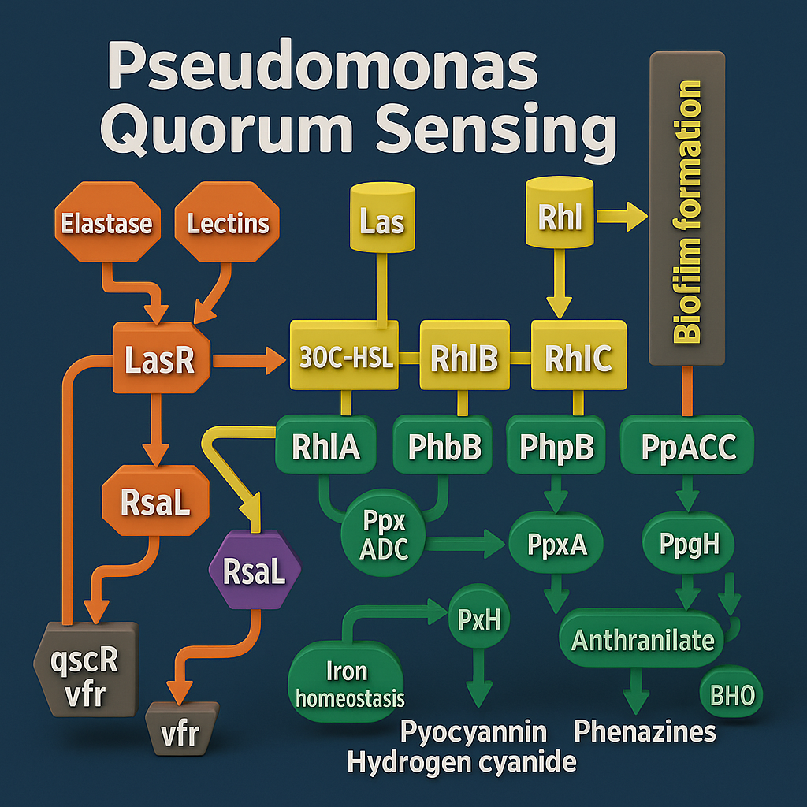

Figure1.3: Pseudomonas aeruginosa Quorum Sensing Pathway

The bacterium QS system also regulates the production of several molecules integral to biofilm development, such as Lectins A and B, rhamnolipids, and iron-chelating siderophores including pyochelin and pyoverdine (Sass et al., 2017; Newman, Floyd and Fothergill, 2017). Additionally, QS facilitates the release of extracellular DNA (eDNA) during the later stages of biofilm maturation, a process driven by QS-induced autolysis (Panlilio, H. and Rice, 2021).

**1.2.2. Biofilm Formation by Pseudomonas aeruginosa**

Biofilms are complex, heterogeneous microbial communities composed of bacterial microcolonies embedded within a self-secreted matrix that adheres to both biotic and abiotic surfaces (Saini et al., 2023). Biofilm enhances the pathogenicity of Pseudomonas aeruginosa by promoting tissue invasion, and immune evasion, contributing to infection, pulmonary infliction, and the complex pathology observed in cystic fibrosis patients. The sheer bulk of the biofilm, combined with its structural complexity, enhances its stability, reduces susceptibility to antibiotic activity, increases resistivity to immune hostility, impairs phagocytic capability, and encapsulates bacterial communities within a protective locality that facilitates selective nutrient diffusion while excluding host-derived toxicity, altogether promoting infection chronicity, long-term inflammatory morbidity, and supporting biofilm durability, adaptability, and pathogenicity within host tissues (Moser et al., 2021; Maurice, Bedi and Sadikot, 2018; Gomez et al., 2023). The matrix, a complex and cohesive entity, is composed of exopolysaccharides (Di Martino, 2018), proteins (Reichhardt et al., 2020), extracellular DNA and lipids, forming a foundation of remarkable stability (Santajit and Indrawattana, 2016; Devaraj et al., 2019). The development of a biofilm involves **five stages**: initial attachment, irreversible adherence, proliferation and microcolony formation, maturation,anddispersal (Vadakkan et al., 2018). In the dispersal stage, some bacterial cells detach and colonize new niches (Muhammad et al., 2020; Yin et al., 2019). In cystic fibrosis, dispersal contributes to the persistence and recurrence of Pseudomonas aeruginosa infections, making it a major therapeutic challenge.

**1.2.3. Resistance Mechanisms of**Pseudomonas aeruginosa

Pseudomonas aeruginosa resistance to a broad spectrum of antibiotics, including β-lactams, aminoglycosides, and quinolones (Hancock and Speert, 2000; Vadakkan et al., 2023)) can be categorized into **intrinsic, acquired,** and **adaptive types**. The**intrinsic resistance** of Pseudomonas aeruginosa is its innate ability to reduce the efficacy of antibiotics due to its structural and functional characteristics (Blair et al., 2015) such as its low outer membrane permeability, efflux pump system, and production of β-lactamases (Pachori, Gothalwal et al., 2019). The **acquired resistance**arises through horizontal gene transfer or spontaneous mutations, enabling the bacterium to survive antibiotic treatment (Breidenstein et al., 2011) and spread this resistance swiftly among bacterial populations. The bacterium can **adapt to** suboptimal conditions, including antibiotic exposure, by forming biofilms and generating persister cells, which are capable of surviving antibiotic treatment and facilitating chronic infection and recolonization (Lewis, 2008; Grassi, Di Luca et al., 2017).

**1.3.1. Meropenem: a carbapenem antibiotic**

Meropenem is a carbapenem, a β-Lactam antibiotic. β-Lactam antibiotics are subdivided into four: penicillin, cephalosporins, carbapenems, and monobactams (Bush and Bradford, 2016). The bacterial cell wall is composed of peptidoglycan, a mesh-like structure formed by polysaccharide chains arranged in a three-dimensional lattice. These chains are made up of alternating units of N-acetylglucosamine (NAG) and N-acetylmuramic acid (NAM), cross-linked by short peptide chains. The cross-linking is mediated by the enzymatic activity of D-alanyl-D-alanine-transpeptidases, also known as penicillin-binding proteins (PBPs) (Yadav, Espaillat, and Cava, 2018). β-Lactam antibiotics exert their bactericidal effect by inhibiting these PBPs, thereby preventing the formation of peptide cross-links (Chifiriuc et al., 2016). This disruption results in defective cell wall biosynthesis and osmotic lysis (Cho, Uehara, and Bernhardt, 2014; Kapoor, Saigal et al., 2017).

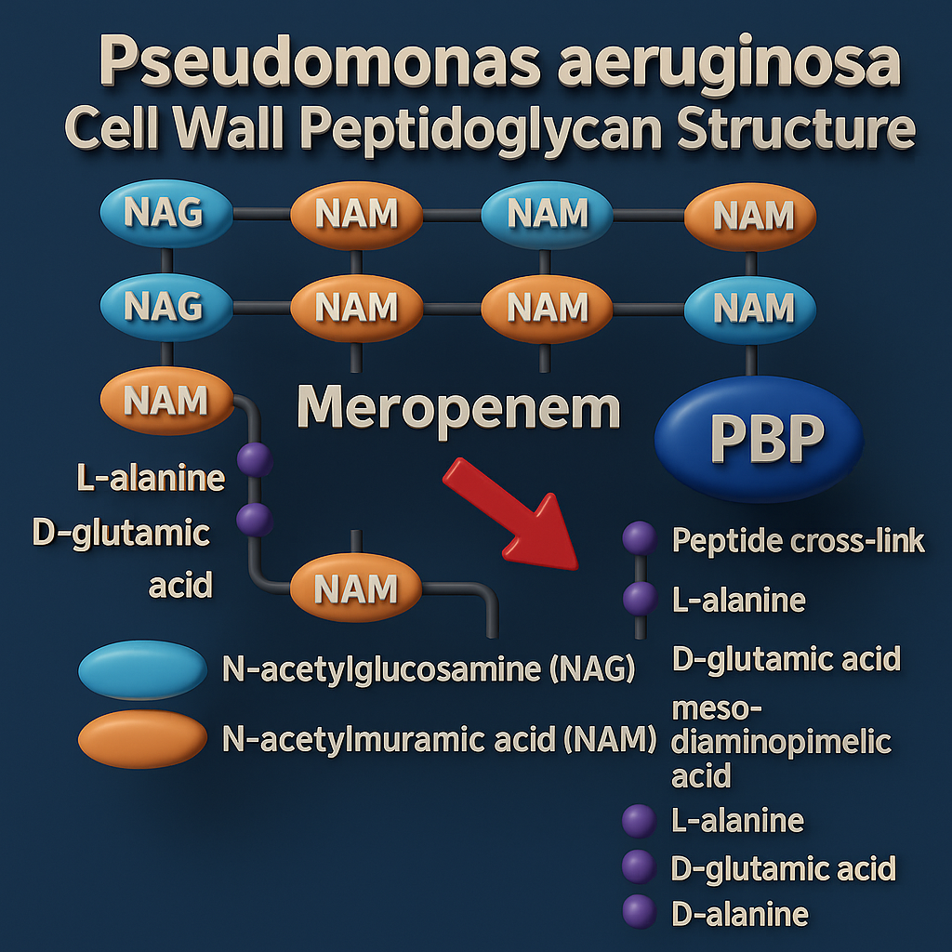

Figure 1.4: Pseudomonas aeruginosa cell wall structure (prepared using Canva)

Two key mechanisms underlie resistance to β-lactam antibiotics: the production of β-lactamase enzymes and the alteration of PBPs. Mutations in the ftsI gene, which encodes PBP3, result in an altered protein with diminished affinity for β-lactam antibiotics.

Meropenem is active against anaerobic bacteria, Gram-positive cocci and Gram-negative bacilli (Boonpeng et al., 2022)), including Pseudomonas aeruginosa (Hurst and Lamb, 2000b). Its plasma protein binding is 2%, and its half-life is approximately one hour in adults (Tröger and Meyer, 1995; Fish, 2006), two hours in neonates and three hours in preterm neonates (Pacifici, 2019). Following intravenous administration, approximately 70% of the drug is excreted via glomerular filtration and tubular secretion in the urine (Dong et al., 2022; Thalhammer, Schenk et al., 1998).

Meropenem shows limited stability in aqueous solution. Approximately 90% of the meropenem molecule remains intact after 7.4 hours at 22 °C. Therefore, studies recommend storing the drug in crystalline form prior to use to preserve stability (Fawaz et al., 2019). Current guidelines state that a three-hour infusion must be completed within four hours of reconstitution. (Fawaz, Barton et al., 2019).

Meropenem exhibits time-dependent bactericidal activity, whereby its therapeutic success is determined by the duration that the free drug concentration at the infection site exceeds the minimum inhibitory concentration (%fT > MIC) of the target pathogen during the dosing interval. Prolonged maintenance of blood concentrations above the MIC significantly enhances the likelihood of clinical success (Drusano, 2004; Craig, 1998). The relationship between %fT > MIC and antibacterial effect is illustrated in graph 1, which shows the change in bacterial load (expressed as log₁₀ CFU/thigh) over 24 hours against % time above MIC for Escherichia coli and Pseudomonas aeruginosa.

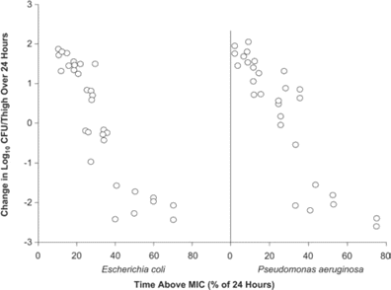

Figure 1.4. The**relationship between the duration of antibiotic exposure (as % of time above MIC over 24 hours)**and the**change in bacterial count (Log₁₀ CFU/thigh) over 24 hours**for **Escherichia coli** and**Pseudomonas aeruginosa** (Nicolau, 2008).

For**Escherichia coli**, there is an inverse relationship between % time above MIC and bacterial count. As the time above MIC increases, there is a marked reduction in bacterial load (more negative log₁₀ CFU values). This suggests time-dependent killing, where longer exposure above MIC improves bacterial killing. For**Pseudomonas aeruginosa**, however, the relationship is less sharp compared to E. coli. Significant bacterial reduction tends to occur when the time above MIC exceeds around 40–60%, but with more variability. This suggests P. aeruginosa is more resistant or requires longer exposure above MIC for effective killing. The scatter also indicates greater pharmacodynamic variability.

**1.4.1. Thyme Oil: Composition, Antimicrobial and Pharmaceutical Applications**

**Thyme oil**, an essential oil extracted primarily from Thymus vulgaris, exhibits antioxidative, and antimicrobial properties (Pesavento et al., 2015; Galovičová et al., 2021; Wu, Lin and Zhong, 2014) against Gram-positive and Gram-negative bacteria such as Salmonella enteritidis, Escherichia coli, and Listeria monocytogenes. The main bioactive constituents of thyme oil are**monoterpenoids**: thymol (20–60%), c**arvacrol**, **p-Cymene**, **γ-Terpinene**, **linalool**, and **borneol** (Vassiliou et al., 2023)**.** Among these,**thymol**and**carvacrol**are primarily responsible for its antimicrobial and anti-inflammatory activity. Their mechanism involves disruption of bacterial cell membranes, increased permeability, and leakage of cellular contents. **Thymol** is antibacterial, antifungal, antitumour, antiparasitic, anti-inflammatory and antioxidative. It is lipophilic, allowing it to cross cell membranes of the respiratory tract, skin, and GIT and is metabolised in the liver, through glucuronidation and sulfation and is excreted in the urine and faeces. **Carvacrol** possesses antimicrobial and anti-inflammatory properties.It suppresses pro-inflammatory cytokines IL-1B and increase anti-inflammatory cytokines (IL-10) (Wijesundara et al., 2022).

**P-Cymene** exhibits antiviral, antioxidant, and antitumour properties (Ose et al., 2019). **Gamma Terpinene** shows antimicrobial and antioxidant properties.Linalool is amonoterpene alcohol with antimicrobial and anti-inflammatory properties.

Recently, research has focused on improving thyme oil’s efficacy and stability and minimizing its degradation by incorporating it into advanced drug delivery systems. Nano emulsions and lipid-based nanoparticles enhance its solubility, bioavailability, and controlled release, providing sustained antimicrobial activity. Synergistic combinations of thyme oil with conventional antibiotics have shown promising results in reducing minimum inhibitory concentrations (MICs) and enhancing activity against drug-resistant pathogens, suggesting its potential role in combination therapy. **He et al. (2021)**prepared thyme essential oil nano emulsions using ultrasonic emulsification and demonstrated their enhanced antibacterial efficacy against Escherichia coli O157:H7 and Staphylococcus aureus in comparison to coarse emulsions. The nano emulsions showed considerably lower minimum inhibitory concentrations (MICs) and induced substantial damage to bacterial membranes, leading to increased permeability, leakage of intracellular contents, and eventual cell death. **Binazir et al. (2024)**developed and optimized nanostructured lipid carriers (NLCs) loaded with a thyme–pennyroyal essential oil blend and assessed their antimicrobial efficacy against Pseudomonas aeruginosa, Escherichia coli, and Staphylococcus aureus. **Monsef et al. (2023)**investigated thyme oil-loaded solid lipid and chitosan nanocarriers for their antibacterial activity against Salmonella Typhimurium and Escherichia coli. The nano formulations showed enhanced antimicrobial effects and stability.

**1.5.1. Introduction to Nanostructured Lipid Carriers (NLCs)**

Lipid-based nanoparticles encompass liposomes, solid lipid nanoparticles (SLNs), nanostructured lipid carriers (NLCs), and nano emulsions. These systems offer high bioavailability and payload versatility, especially in the case of SLNs and NLCs (Dhiman, Awasthi et al., 2021). While SLNs often exhibit low encapsulation efficiency due to their rigid crystalline lipid matrix, leading to drug expulsion and burst release. These drawbacks have been addressed by the development of second-generation lipid nanoparticles, namely NLCs, which incorporate an amorphous lipid matrix to enhance drug loading capacity and extend release profiles (Dhiman, Awasthi et al., 2021).

Lipid nanoparticles comprise surfactants and endogenous lipids or their analogues, rendering them biocompatible, biodegradable, and nontoxic (Mehnert and Mäder, 2001). Lipid nanoparticles exist in two categories (Duong et al., 2020): solid lipid nanoparticles and nanostructured lipid carriers. Type 1 NLCs (imperfect crystal form) contain disordered matrix with spaces and voids produced because of varying chain lengths of fatty acids and the presence of a mixture of mono-, di-, and triacylglycerols. While the incorporation of spatially diverse lipids enhances the drug loading capacity, this disordered matrix typically results in reduced entrapment efficiency (Selvamuthukumar and Velmurugan, 2012). There are three categories of nanostructured lipid carriers. Type II NLCs (multiple type) are characterised by a complex architecture with multiple lipid phases. NLC Type III (Amorphous Model) are formulated by carefully selecting and mixing special lipids to prevent drug expulsion associated with lipid crystallization. Lipids such as hydroxyl octacosanyl, hydroxyl stearate, isopropyl myristate, and dibutyl adipate are used to form solid yet non-crystalline particles. Resultantly, the lipid matrix remains in a homogeneous amorphous state, which helps maintain drug stability and minimize leakage during storage (Müller, Radtke and Wissing, 2002). This blend creates structural imperfections, leading to a disordered, less tightly packed lipid matrix, which impedes drug leakage (Zeb et al., 2018b; Azar et al., 2020) and facilitates a high drug loading capacity, better release characteristics (Hu et al., 2006), and enhanced stability. NLCs overcome the flaws inherent in solid lipid nanoparticles such as their suboptimal drug encapsulation efficiency and the propensity for drug expulsion due to recrystallisation of lipids over prolonged storage periods (Zielinska et al., 2019; Khosa, Reddi, and Saha, 2018). Nanostructured lipid carriers (NLCs) are composed of an outer surfactant layer encapsulating an inner matrix that comprises both amorphous liquid lipids and crystalline solid lipids (Figure 1), with particle sizes typically ranging from 10 to 1000 nm(Mukherjee, Ray, and Thakur, 2009).

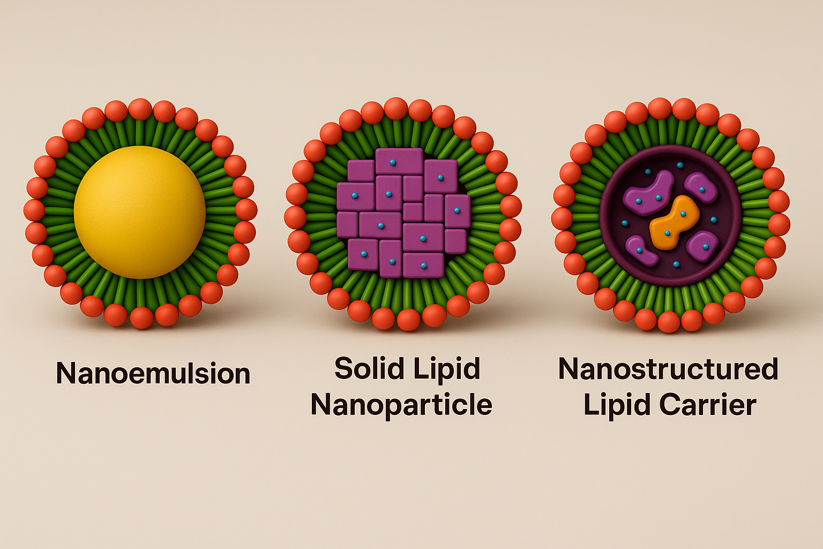

Figure1.5: Illustration displaying the structures of NE, SLN, and NLC

**Table1.1. Lipids Used in NLCs.**

|  |  |  |
| --- | --- | --- |
| **Category** | **Solid Lipids** | **Liquid Lipids** |
| **Long-chain FA (≥C14)** | **Stearic acid** (Phunpee et al., 2020) **Palmitic acid** (Chesneau et al., 2021) **Myristic acid** (Chesneau et al., 2021) **Cetyl palmitate** (Iurciuc et al., 2021) | **Argan oil** (Silva et al., 2021) **Castor oil** (Prabhdial et al., 2021) **Olive oil** (De Barros et al., 2021) **Oleic acid** (Parra Arrieta et al., 2020; Temraz and Kassem, 2024) |
| **Medium-chain FA (C8–C12)** | **Lauric acid** (Orienti et al., 2021) **Capric acid** (Orienti et al., 2021) | **Glyceryl tricaprylate** (Jansen et al., 2018) **Glyceryl dicaprate** (Phad et al., 2021) **Caprylic acid** (Parra Arrieta et al., 2024) |
| **Triglycerides** | **Glyceryl monostearate** (Chesneau et al., 2021; Taonezlodabeh et al., 2022) **Glyceryl Tri stearate** (Dynasan 118) **Glyceryl tripalmitate** (Dynasan 116) (Sanad et al., 2022) **Glyceryl Tri myristate** (Dynasan 114) **Glyceryl palmitostearate** (Precirol ATO5) (Chesneau et al., 2021) | **Miglyol 808** (Jarvis et al., 2016) **Miglyol 812** (Tians et al., 2017) **Caprylic triglyceride** (Zhou et al., 2021) |
| **Waxes** | **Beeswax** **Carnauba wax** (Lucena et al., 2021) | – |
| **Butters** | **Cocoa butter** (Linder et al., 2017) **Shea butter** (Aljaeid et al., 2021) | – |

|  |  |  |  |
| --- | --- | --- | --- |
| **Table 1.2: Surfactants Used in NLCs Preparation.** | | | |
| **Surfactant** | **Nature** | **HLB (Hydrophilic-Lipophilic Balance)** | **Citation** |
| **Tween 20** | Hydrophilic | 16.7 | (Saeedi et al., 2023) |
| **Tween 80** | Hydrophilic | 15 | (Pa, 2014) |
| **Poloxamer 188** | Hydrophilic | 29 | (Rajinikanth & Chellian, 2016) |
| **Poloxamer 407** | Hydrophilic | 23 | (Rosen, 2005) |
| **Cremophor RH40** | Hydrophilic | 14 | (Izza et al., 2021b) |
| **Cremophor EL** | Hydrophilic | 13 | (Rosen, 2005) |
| **Kolliphor HS15** | Hydrophilic | 16 | (Izza et al., 2021) |
| **Sodium deoxycholate** | Hydrophilic | 17 | (Rosen, 2005) |
| **Sodium Tauro deoxycholate** | Hydrophilic | 17 | (Rosen, 2005) |
| **Lecithin** | Amphiphilic | 4–9 | (Elmowafy et al., 2017) |

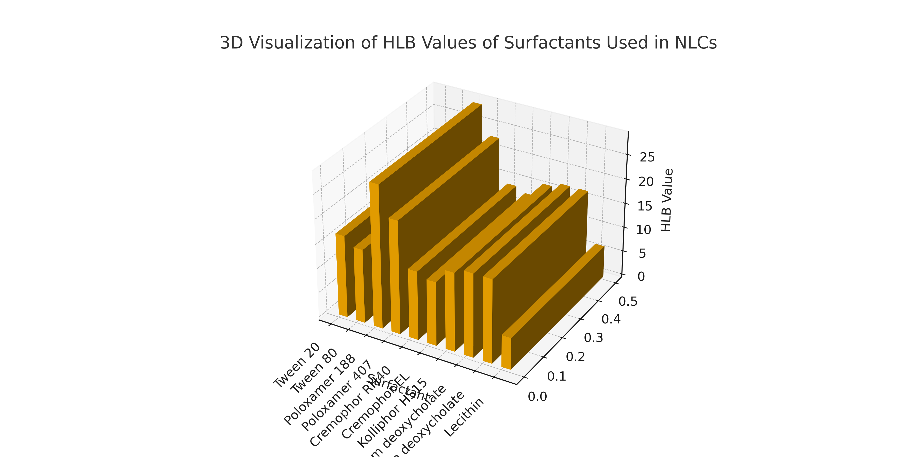

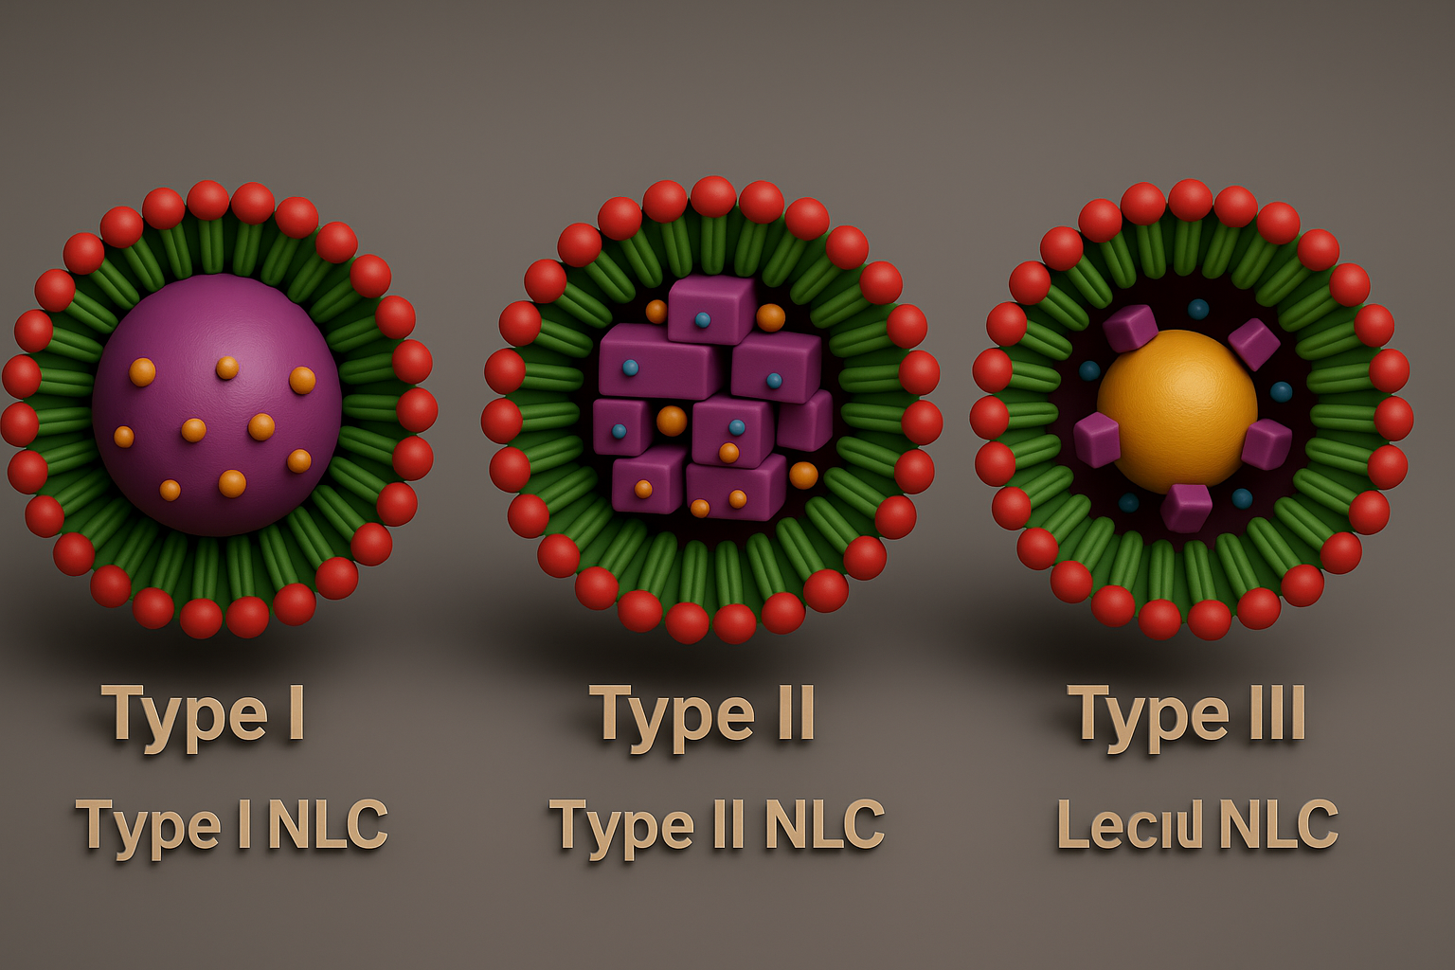

Figure: Illustration comparing Type I, Type II, and Type III.

The merits of NLCs are their versatility, protection of encapsulated drugs from degradation, heightened drug loading efficiency, enhanced bioavailability, improved stability, and the ability to regulate drug release kinetics (Khosa, Reddi, and Saha, 2018). Notably, the encapsulation of beta-lactam antibiotics within cationic NLCs has been demonstrated to boost curative efficacy by enhancing electrostatic interactions with the negatively charged bacterial cell walls (Aflakian, Mirzavi et al., 2023). These attributes are particularly relevant for cystic fibrosis patients, where the viscous mucus hinders effective drug delivery to infection site. The applicability of inhaled nanoparticles for respiratory drug delivery has been demonstrated in lung cancer treatment models, highlighting the potential of NLCs as a drug delivery system for bacterial infections in cystic fibrosis (Ahmad, Akhter et al., 2015).

**1.5.2. The use of NLCs to encapsulate meropenem**

Research into the application of nanostructured lipid carriers (NLCs) for the treatment of bacterial infections holds significant potential in the fight against antimicrobial resistance (AMR). NLCs offer an alternative drug delivery platform that can be employed against both antibiotic-sensitive and -resistant bacterial strains, potentially improving pharmacokinetic profiles, reducing systemic toxicity, and decreasing the rate of drug elimination.

The clinical utility of meropenem is limited by its physicochemical instability in aqueous solutions, necessitating intravenous administration. To address these limitations, encapsulating meropenem within nanostructured lipid carriers (NLCs) has been proposed as a strategy to enhance its stability (Nguyen et al., 2022), improve controlled drug release, and facilitate alternative routes of administration such as an inhalation therapy for pulmonary infections.

Rajpoot et al. (2022) prepared meropenem-loaded nanostructured lipid carriers (MPM-NLCs) aimed at treating skin and soft tissue infections (SSTIs) caused by Staphylococcus aureus. The NLCs were optimized using a central composite design (CCD) and characterized for particle size, zeta potential, entrapment efficiency, and drug release. The optimized formulation exhibited high encapsulation efficiency (~84%), and sustained drug release. In vitro and ex vivo studies demonstrated enhanced antimicrobial activity, improved skin permeation, and prolonged retention compared to free meropenem, suggesting the potential of NLCs as an effective topical delivery system for resistant staphylococcal infections.

**1.6. Aims and objectives**

**1.6.1. Aims**

The aim of the study was to optimise and develop meropenem encapsulated nanostructured lipid carriers (MPM-NLCs) and NLCs co-loaded with meropenem and thyme oil (MPM-TO-NLCs) to evaluate the use of these formulations as an antimicrobial therapy for Pseudomonas aeruginosa infection in cystic fibrosis lung infection.

**1.6.2. Specific objectives**

1. To develop meropenem-encapsulated nanostructured lipid carriers (MPM-NLCs) and formulations coloaded with thyme oil.

2. To analyse NLCs for drug loading and entrapment efficiency.

3. To characterize the physicochemical properties of the formulations.

4. To use a high-performance liquid chromatography (HPLC) method for the quantification of meropenem in NLCs.

**Chapter 2: Material and methods**

**2.1. Chemicals and Reagents**

**Meropenem** was purchased from Activate Scientific GmbH (Prien am Chiemsee, Germany). **Sodium cholate** and **Oleic acid** were purchased from Sigma Aldrich (Gillingham, United Kingdom). **Capryol 90** and **Transcutol** were purchased from Gattefosse (Neuilly-sur-Seine, France), **Phospholipon 90 H**, **lipoid S100** and **S75** were purchased from Lipoid (Ludwigshafen, Germany). **Dynasan 114** was purchased from Emery Oleochemicals (Hampshire, UK). **Thyme oil** was purchased from Holland and Berret (Preston, UK). Amicon™ 30 kDa filters were purchased from Merck Millipore (UK).

**2.2.1 Preparation and Formulation of Nanostructured Lipid Carriers**

Blank nanostructured lipid carriers (NLCs) meropenem-loaded NLCs (MPM-NLCs), and meropenem-thyme-loaded NLCs (MPM-TO-NLCs) were prepared using a hot homogenization method. The aqueous phase was prepared by dissolving sodium cholate in Milli-Q water (Sigma-Aldrich, UK). The lipid phase consisted of Phospholipon 90 H, Lipoid E100, Lipoid S75,PEG Stearate**,** Dynasan 114, and oleic acid, capryol90, meropenem and thymol oil (Tables 2.1).

|  |  |  |  |  |  |  |  |  |  |  |  |  |
| --- | --- | --- | --- | --- | --- | --- | --- | --- | --- | --- | --- | --- |
| **Formulation** | **Aqueous Phase** | | **Lipid Phase** | | | | | | | | | |
| **Milli-Q Water (ml)** | **Sodium Cholate (mg)** | **Lipoid S100** | **Lipoid S75** | **Phospholipon 90H (mg)** | **Dynasan114 (mg)** | **PEG Stearate (mg)** | **Oleic Acid** | **Capryol 90 (mg)** | **Meropenem (mg)** | **Thymol Oil (mg)** |
| 1 | 15 | 90 | 180 | 180 | 48 | 600 | N/A | 100 | 120 | N/A | N/A |
| 2 | 15 | 90 | 180 | 180 | 48 | 400 | 200 | 100 | 120 | N/A | N/A |
| 3 | 15 | 90 | 180 | 180 | 48 | 400 | 200 | 100 | 120 | 7.5 | 180 |
| 4 | 15 | 90 | 180 | 180 | 48 | 400 | 200 | 100 | 120 | 7.5 | 200 |
| 5 | 15 | 90 | 180 | 180 | 48 | 400 | 200 | 100 | 120 | 7.5 | 220 |
| 6 | 15 | 90 | 180 | 180 | 48 | 400 | 200 | 100 | 120 | 7.5 | 240 |

Both phases were separately heated in water baths at 80 °C for 30 minutes. The hot aqueous phase was then added to the lipid phase and dispersed under constant stirring using a magnetic stirrer for 30 minutes to produce a coarse emulsion (Duong, Nguyen et al., 2020). Subsequently, the emulsion underwent homogenization via a Sonic Vibra-Cell probe sonicator (Sonics & Materials Inc., USA) for 6 minutes at 40% amplitude, aiming to enhance dispersion and reduce particle size (Lasoń, Sikora et al., 2013). Finally, the homogenized product was allowed to cool to room temperature, resulting in the formation of stable

**2.2.2. NLCs Characterization**

The formulations were subjected to physicochemical characterisation to evaluate the impact of thyme oil on particle morphology, stability, and structural uniformity. The particle size, polydispersity index (PDI), and zeta potential (ZP) of all formulations were determined using dynamic light scattering (DLS) at scattering angles of 90° and 173°, with a laser wavelength of 633 nm at 25°C, employing a Malvern Zetasizer Nano Advance (Malvern Instruments, UK) (Mhango, Kalhapure et al., 2017). Samples were diluted with deionised water to avoid multiple scattering effects. Each analysis was performed in triplicate to ensure reproducibility. Particular attention was rendered to evaluating the influence of thyme oil concentration on the physiochemical characteristics.

**2.2.3. Lyophilization of NLCs**

Lyophilization was conducted by mixing 1 mL of sucrose cryoprotectant solution, at concentrations of 7% and 10%, with 1 mL of ME-NLCs and ME-Thyme-NLCs dispersions. The mixtures were frozen at –70 °C for 24 hours. Subsequently, the frozen samples were transferred to a Christ Alpha 2-4 LDplus freeze dryer (Martin Christ Gefriertrocknungsanlagen GmbH, Germany) and lyophilized at –80 °C for 48 hours (Khan, Mudassir et al., 2019). Upon complete lyophilization, samples were sealed and stored at –20 °C for one week. Following reconstitution with 2 mL of Milli-Q water, the samples were analysed for changes in particle size, polydispersity index (PDI), and zeta potential (ZP).

**2.5. High-Performance Liquid Chromatography of Meropenem**

A HPLC method developed and validated by Connor was used to quantify meropenem and thyme in NLCs and determine the drug loading.

**2.5.1 Preparation of Mobile Phase Orthophosphate Buffer**

The orthophosphate buffer was prepared with monobasic potassium phosphate (680 mg) and triethanolamine (1130 mg). These compounds were accurately weighed and dissolved in 400ml of Milli-Q water. The solution was then transferred to a volumetric flask, and the volume was then made up to 500ml with Milli-Q water prior to decanting into Duran bottle. The buffer’s pH was then adjusted from a slightly basic pH (around pH 8) to pH 2.7 with orthophosphoric acid added dropwise, using a pH meter.

**4.5. Linearity of HPLC Method**

A stock solution of meropenem was prepared by dissolving 10 mg of the drug in 10 mL of distilled water. This stock solution was subsequently diluted to obtain working standard solutions at concentrations of 2, 4, 8, 10, 16, and 20 µg/mL. High-performance liquid chromatography (HPLC) analysis was performed in triplicate for each concentration level.

**2.5.8. Preparation of Sample Solution for Analysis of Drug Loading**

The entrapment efficiency (EE) of the formulation was determined by quantifying free drug in the supernatant fluid, which was separated by filtering NLCs (0.5 ml) using Amicon™ 30 kDa molecular centrifuge filters purchased from Merck Millipore (UK) centrifuged at 13000 rpm for 30 minutes. The supernatant was then removed using a pipette, diluted 1:100 and analysed immediately. The linearity curve was used to calculate the concentration of free drug. Equation 1 was then used to determine the %EE.

**%EE= Total Drug-Suspended Drug/Total Drug*100**

**Chapter 3: Results**

3.1. **Effect of Varying Concentrations of Thyme Oil on the Physiochemical Characteristics of NLCs**

The effect of increasing thyme oil concentration on the physicochemical characteristics of nanostructured lipid carriers (NLCs) was evaluated through Z-average particle size, polydispersity index (PI), and zeta potential (ZP) (Table 3.1). The control formulation (MpM-NLCs) without thyme oil exhibited the smallest particle size (51.35 nm), while progressive addition of thyme oil led to an increase in size, reaching a maximum of 88.73 nm in MpM-TO-NLC240). The control formulation exhibited a PI value of 0.269, and a ZP of -32.53 mV. Nevertheless, formulations containing thyme oil showed increased particle sizes ranging from 70.63 nm (MpM-TO-NLC180) to 88.73 nm (MpM-TO-NLC240). Their PI values ranged from 0.1518 to 0.2518 across the thyme oil-loaded NLCs, indicating variation in particle size distribution. Zeta potential values remained consistently negative, ranging from -32.22 mV to -35.36 mV, suggesting stability of the formulations. PI values remained below 0.3 across all formulations, with the lowest value recorded for MpM-TO-NLC220 (0.1518), indicating a narrow particle size distribution (figure 3.1;3.2).

|  |  |  |
| --- | --- | --- |
| **Table 3.1: The Effect of Thyme Oil on the Physiochemical Characteristics of NLCs** | | |
| **Formulation** | **Parameter** | **Value** |
| **Batch A (without TO)** | Z-average | 51.35 |
| PI | 0.269 |
| ZP | -32.53 |
| **Batch B (TO=180mg)** | Z-average | 70.63 |
|  | PI | 0.237 |
| ZP | -33.86 |
| **Batch C (TO=200mg)** | Z-average | 72.42 |
| PI | 0.2021 |
| ZP | -33.99 |
| **Batch D (TO=220mg)** | Z-average | 80.56 |
| PI | 0.1518 |
| ZP | -32.22 |
| **Batch E( TO=240mg)** | Z-average | 88.73 |
| PI | 0.2518 |
| ZP | -33.22 |

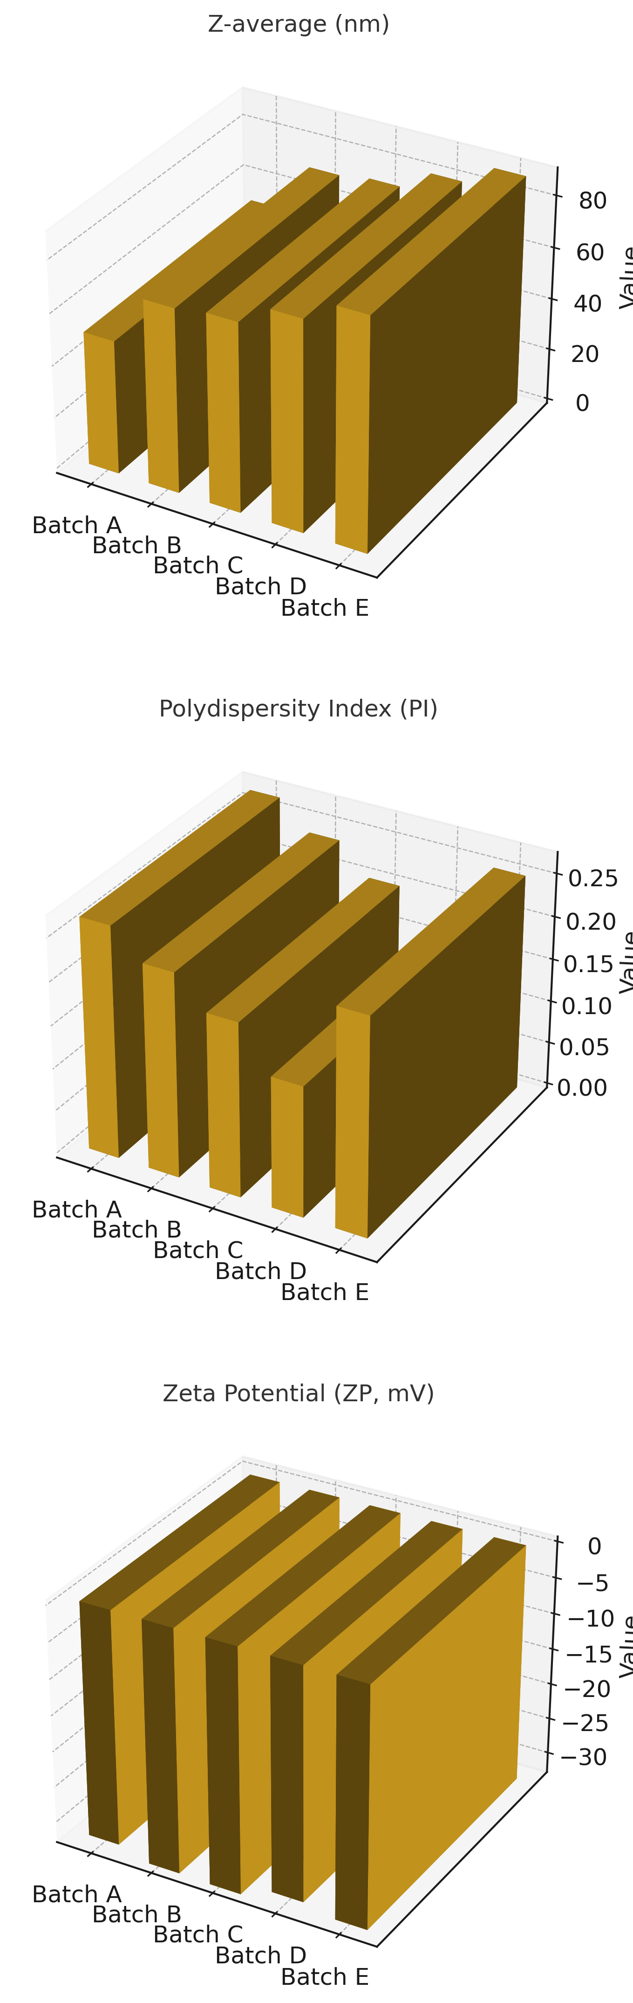

Figure 3.1: Bar graph showing changes in physiochemical characteristics.

# Radar Chart of NLC Physicochemical Characteristics

This radar chart illustrates the normalized values of Z-average (nm), Polydispersity Index (PI), and Zeta Potential (ZP, mV) for five different NLC batches (A to E).

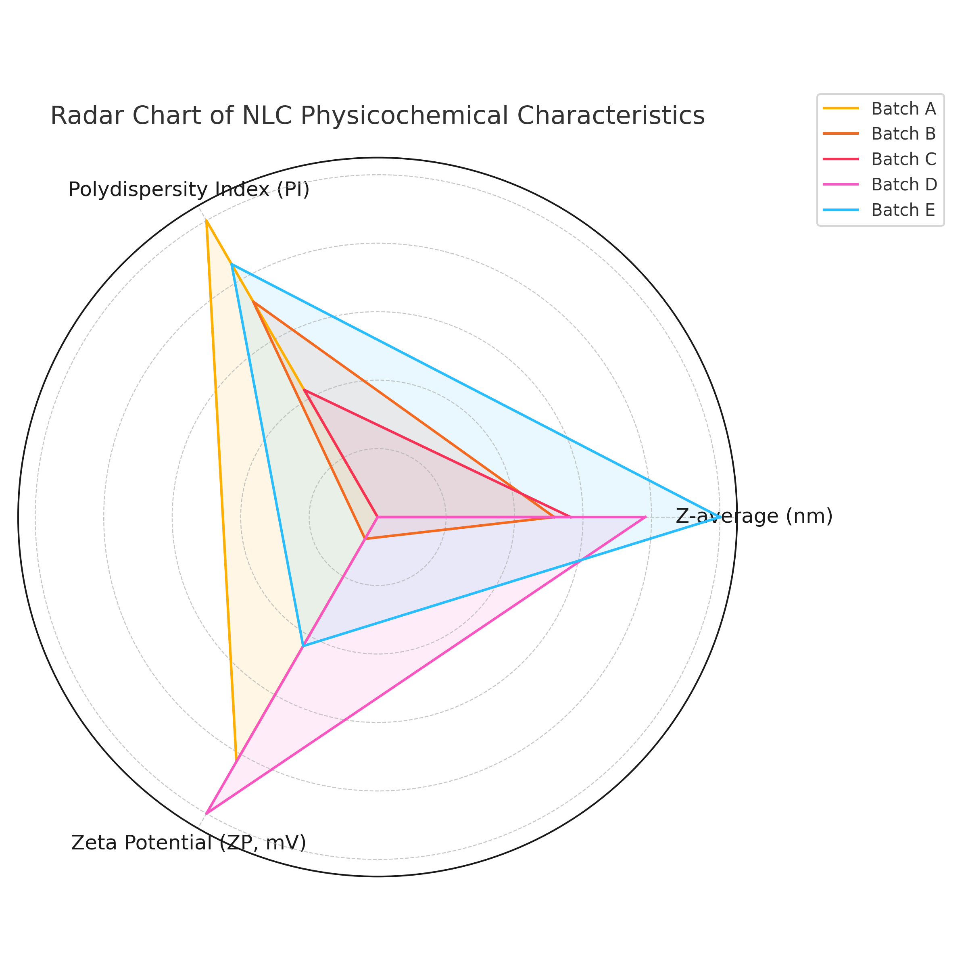

Figure 3.2: Radar chart showing changes in physiochemical characteristics.

**3.2. Stability Assessment of the Formulations over Time and at Different Temperatures**

The stability of blank meropenem-loaded NLCs (MpM-NLCs), MpM-TO-NLC formulations (180, 200, 220, 240 ug) was evaluated over 24 and 48 hours at 20 °C and 37 °C by monitoring changes in particle size, polydispersity index (PDI), and zeta potential. For Blank NLCs, particle size increased steadily at both 20 °C (from 98.48 nm to 122.6 nm) and 37 °C (from 99.49 nm to 160.2 nm) over 48 hours. PDI showed an initial increase at 24 hours then decreased at 48 hours at 20 °C, while at 37 °C it remained variable. Zeta potential values became slightly less negative at 20 °C and more negative at 37 °C. In**MpM-NLCs**, particle size increased considerably at 20 °C from 51.35 nm to 115.2 nm by 48 hours. However, at 37 °C, the particle size stayed stable around 51.5 nm throughout. PDI rose substantially at 20 °C, while at 37 °C, a modest increase was noted. Zeta potential decreased slightly over time at both temperatures. For**MpM-TO-NLC180**, particle size increased at both 20 °C and 37 °C, with a more prominent change observed at 20 °C. PDI also increased at both temperatures. Zeta potential stayed stable with minor fluctuations. MPM-TO-NLC200 showed minimal changes in particle size and PDI over time at both temperatures. Zeta potential values remained consistent. In**MpM-TO-NLC220**, particle size increased with time, especially at 37 °C (from 80.56 nm to 138.5 nm). PDI showed slight variability, and zeta potential remained in a similar range. MpM-TO-NLC240 exhibited a gradual increase in particle size at both temperatures. PDI fluctuated slightly, and zeta potential stayed relatively stable.

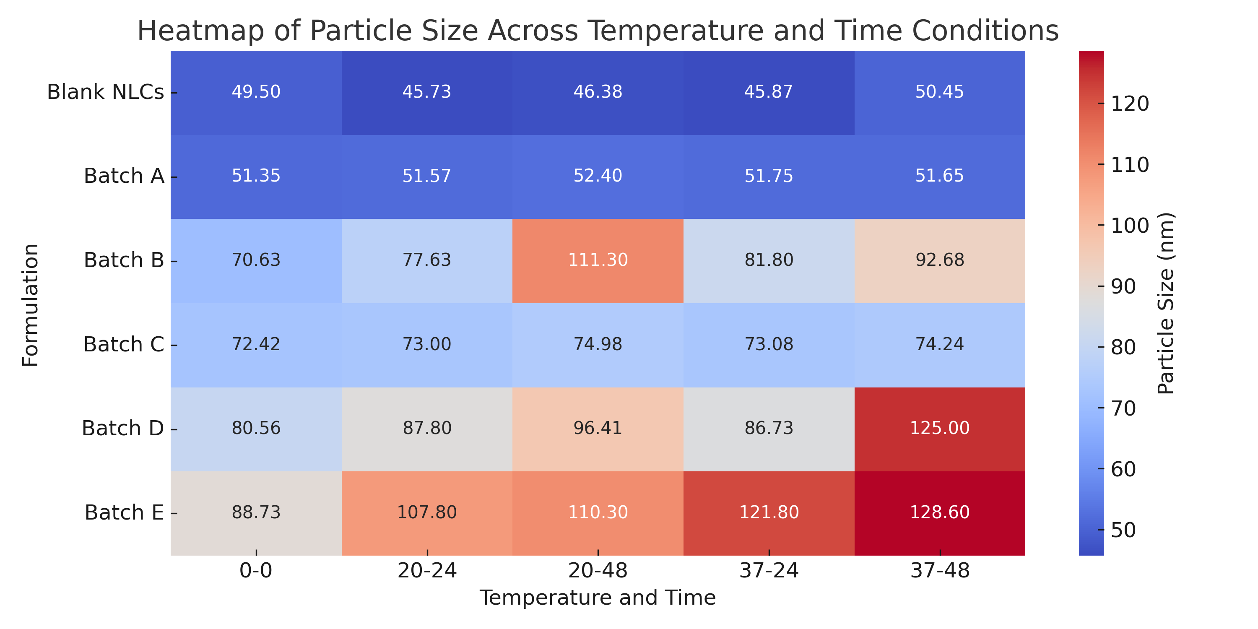

Figure3.3. Illustration of particle size variations of NLC formulations under various storage conditions over time.

**3.3. Effect of Sonication Time on the Physiochemical Characteristics**

The impact of sonication time (3 minutes vs. 6 minutes) on the physicochemical characteristics of various nanostructured lipid carrier (NLC) formulations was analysed by measuring Z-average particle size, polydispersity index (PI), and zeta potential (ZP).

For the**Blank NLC**, increasing the sonication time from 3 to 6 minutes resulted in a remarkable reduction in particle size from 98.48 nm to 45.50 nm, accompanied by a decrease in PI from 0.4381 to 0.226 and an enhancement in ZP from –26.88 mV to –35.75 mV. For **MpM-NLC** formulation, particle size was reduced from 107.8 nm at 3 minutes to 51.35 nm at 6 minutes. The PI decreased from 0.4545 to 0.269, while the ZP improved from –29.81 mV to –32.53 mV. For **MpM-TO-NLC180**, sonication for 6 minutes led to a reduction in particle size from 92.68 nm to 70.63 nm. The PI decreased from 0.3992 to 0.2021, and ZP increased in negativity from –28.34 mV to –33.34 mV. In the case of**MpM-TO-NLC200**, particle size decreased from 117.8 nm at 3 minutes to 72.42 nm at 6 minutes. The PI was reduced from 0.451 to 0.212, and the ZP remained constant at –31.52 mV. For**MpM-TO-NLC220**, the particle size dropped from 91.91 nm to 80.56 nm following extended sonication. The PI reduced from 0.3952 to 0.1518, and ZP increased slightly in negativity from –29.52 mV to –32.22 mV. Lastly, the**MpM-TO-NLC240**formulation exhibited a particle size decrease from 96.41 nm at 3 minutes to 88.73 nm at 6 minutes. The PI also declined from 0.4155 to 0.2764, and ZP shifted from –27.36 mV to –30.97 mV.

All formulations demonstrated a consistent trend of reduced particle size and PI values with increased sonication time, accompanied by more negative zeta potential readings.

Table 3.2: Effect of Sonication Time on Different NLC Formulations

|  |  |  |  |  |
| --- | --- | --- | --- | --- |
| **Formulation** | **Sonication Time** | **Z-average (nm)** | **Polydispersity Index (PI)** | **Zeta Potential (mV)** |
| **Blank NLC** | 3 min | 98.48 | 0.4381 | -26.88 |
| 6 min | 45.5 | 0.226 | -35.75 |
| **Batch A** | 3 min | 107.8 | 0.4545 | -29.81 |
| 6 min | 51.35 | 0.269 | -33.34 |
| **Batch B** | 3 min | 92.68 | 0.3992 | -28.34 |
| 6 min | 70.63 | 0.2021 | -33.34 |
| **Batch C** | 3 min | 117.8 | 0.451 | -29.44 |
| 6 min | 72.42 | 0.212 | -31.52 |
| **Batch D** | 3 min | 91.91 | 0.3952 | -29.52 |
| 6 min | 80.56 | 0.1518 | -32.22 |
| **Batch E** | 3 min | 96.41 | 0.4155 | -27.36 |
| 6 min | 88.73 | 0.2764 | -33.22 |

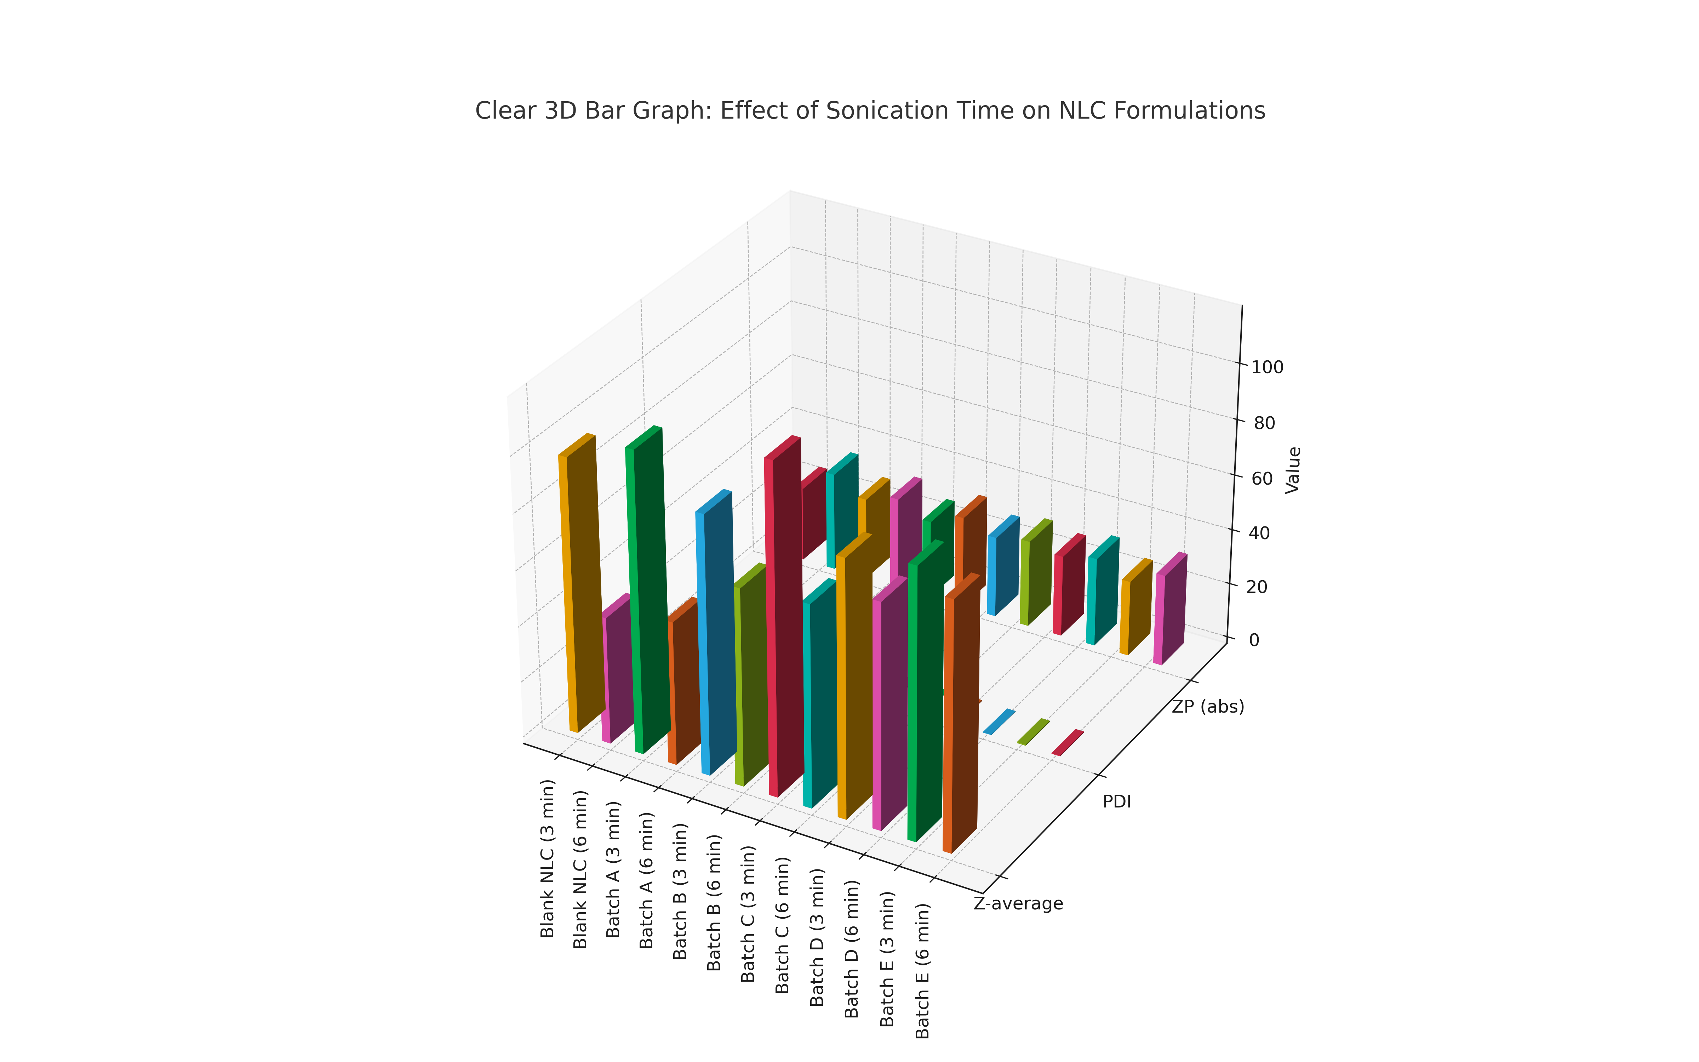

Figure3.5. Effects of sonication time on physicochemical properties of NLCs.

**3.4. Lyophilization of Formulations**

Due to the susceptibility of meropenem to degradation in aqueous environments, lyophilisation of meropenem-loaded nanostructured lipid carriers (MPM-NLCs), including co-loaded formulations (MpM-TO-NLCs180 and MpM-TO-NLCs220), was undertaken to enhance their stability. Sucrose, a widely recognized cryoprotectant, was incorporated at two concentrations (7% and 10%) to assess its protective effect during the freeze-drying process. The impact of sucrose concentration on particle size, polydispersity index (PDI), and zeta potential of the lyophilised NLCs was investigated over a storage period of one week.

|  |  |  |  |  |
| --- | --- | --- | --- | --- |
| **Table 3.3: Effect of Lyophilization and Sucrose Concentration on NLC Formulations** | | | | |
| Formulation | Sucrose Concentration (%) | Particle Size (nm) | PDI | Zeta Potential (mV) |
| Batch A |  | 51.35 | 0.2690 | -32.53 |
| 7 | 98.48 | 0.4381 | -27.00 |
| 10 | 128.60 | 0.3246 | -30.01 |
| Batch B |  | 70.63 | 0.2370 | -33.86 |
| 7 | 86.53 | 0.3796 | -31.45 |
| 10 | 108.10 | 0.4378 | -32.29 |
| Batch D |  | 80.56 | 0.1518 | -32.22 |
| 7 | 140.80 | 0.3979 | -31.87 |
| 10 | 112.60 | 0.4311 | -26.85 |

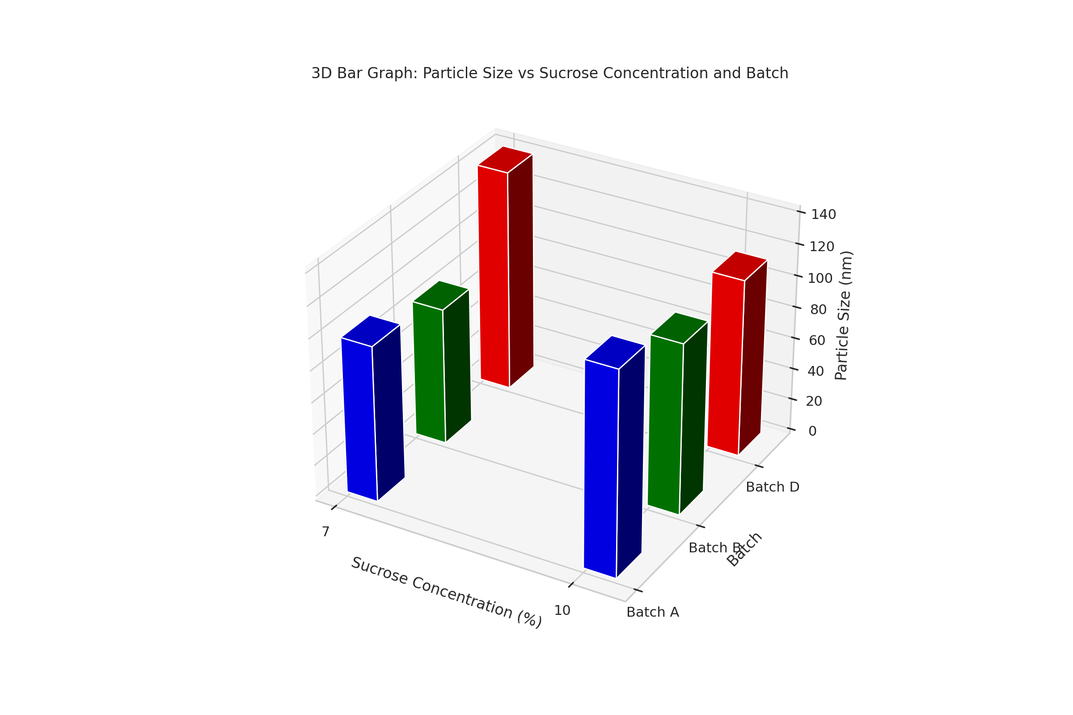

Figure3.6. Effect of lyophilization and sucrose concentrations on physiochemical characteristics of NLCs.

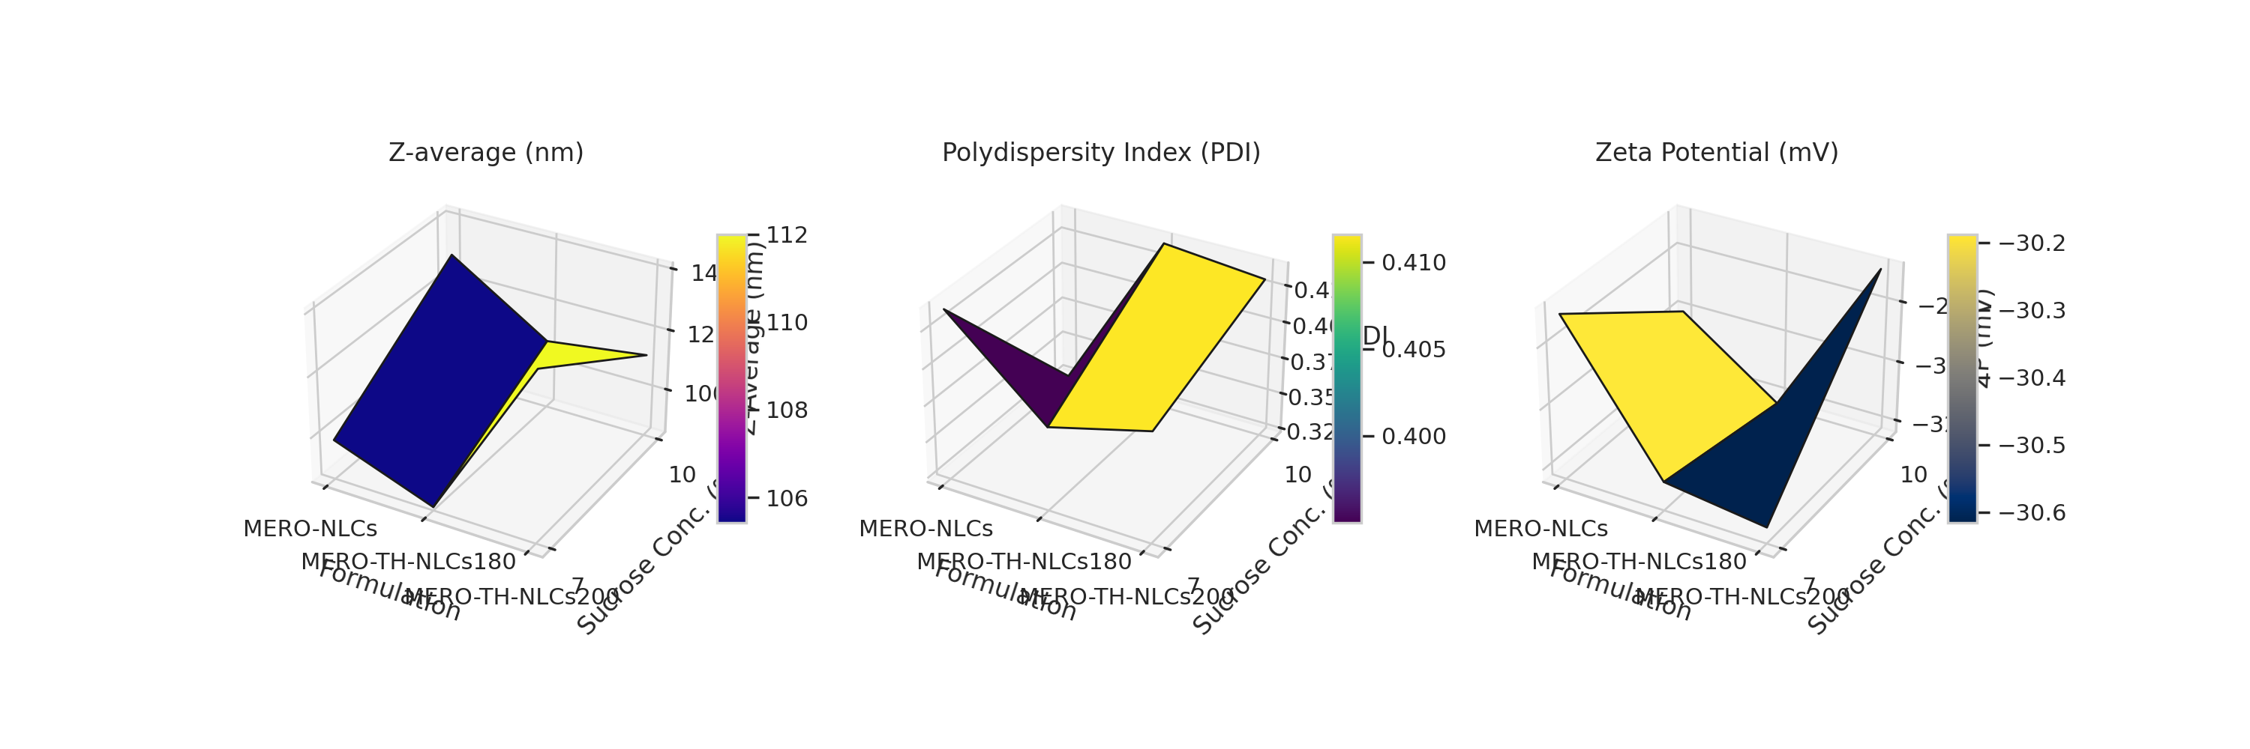

Figure3.7: Influence of sucrose concentration (0%, 7%, 10%) on physicochemical characteristics of NLC formulations.

**3.5. HPLC Analysis of the Formulations**

**3.5.1. Calibration Curve of meropenem in aqueous solution**

To evaluate the linearity of the analytical method, a calibration curve was constructed using known concentrations of the analyte ranging from 0 to 20 units. For each concentration level, the area under the curve (AUC) was measured in triplicate. The mean AUC values were plotted against the corresponding concentrations, and a linear regression analysis was performed. The calibration curve representation is shown in figure 3.8. The resulting peak area values were plotted against concentration, and linear regression analysis was conducted to evaluate the relationship. Data from three independent sets of triplicate measurements were used to calculate the mean and standard deviation, and a calibration curve was constructed in Microsoft Excel. The resulting calibration curve displayed a positive correlation between analyte concentration and the detector response. The regression equation was noted as y=mx+c, where y is the mean AUC and x is analyte concentration. The coefficient determinant (R2) was calculated to be 0.9971, suggesting that 99.71% of the variability in the response of the detector could be explained by the analyte concentration.

This high R² value confirms the**excellent linearity**of the method across the tested range. According to ICH Q2(R1) guidelines, an R² value of ≥ 0.99 is acceptable for establishing linearity in quantitative analytical methods. The minimal deviation from the regression line (only 0.29%) indicates negligible influence from random error or experimental variability, reinforcing the method’s reliability.

Blank

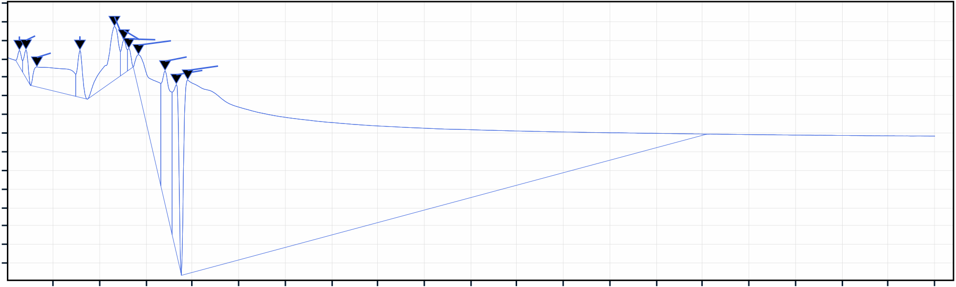

|  |  |  |  |  |  |  |  |  |  |  |  |  |  |
| --- | --- | --- | --- | --- | --- | --- | --- | --- | --- | --- | --- | --- | --- |
| 2 | 0.129 | 0.199 | 0.317 | 0.781 | 1.153 | 1.255 | 1.308 | 1.412 | 1.698 | 1.820 | | 1.942 | |
| 0 |  | |  | |  | |
| -2 |
| -4 |

-6  
-8  
-10

|  |  |
| --- | --- |
| mAU | -12 -14 |

-16  
-18  
-20  
-22  
-24  
-26

|  |  |  |  |  |  |  |  |  |  |  |  |  |  |  |  |  |  |  |  |
| --- | --- | --- | --- | --- | --- | --- | --- | --- | --- | --- | --- | --- | --- | --- | --- | --- | --- | --- | --- |
| 0.5 | 1.0 | 1.5 | 2.0 | 2.5 | 3.0 | 3.5 | 4.0 | 4.5 | 5.0 | 5.5 | 6.0 | 6.5 | 7.0 | 7.5 | 8.0 | 8.5 | 9.0 | 9.5 | 10.0 |

4ug/mL

DAD1A,Sig=308,4 Ref=off

|  |  |
| --- | --- |
| 9  8 | 6.238 |

7   
6   
5

|  |  |  |
| --- | --- | --- |
| mAU | 4 | A graph of a graph  AI-generated content may be incorrect.1. 809 |
| 3 |
| 2 |

1   
0  
-1

|  |  |  |  |  |  |  |  |  |  |  |  |  |  |  |  |  |  |  |  |
| --- | --- | --- | --- | --- | --- | --- | --- | --- | --- | --- | --- | --- | --- | --- | --- | --- | --- | --- | --- |
| 0.5 | 1.0 | 1.5 | 2.0 | 2.5 | 3.0 | 3.5 | 4.0 | 4.5 | 5.0 | 5.5 | 6.0 | 6.5 | 7.0 | 7.5 | 8.0 | 8.5 | 9.0 | 9.5 | 10.0 |

10ug/mL

DAD1A,Sig=308,4 Ref=off

|  |  |
| --- | --- |
| 18 | 6.225 |

16

14

12

|  |  |
| --- | --- |
| mAU | 10  8 |

6

|  |  |
| --- | --- |
| 4  2 | 1.807 |

0

|  |  |  |  |  |  |  |  |  |  |  |  |  |  |  |  |  |  |  |  |
| --- | --- | --- | --- | --- | --- | --- | --- | --- | --- | --- | --- | --- | --- | --- | --- | --- | --- | --- | --- |
| 0.5 | 1.0 | 1.5 | 2.0 | 2.5 | 3.0 | 3.5 | 4.0 | 4.5 | 5.0 | 5.5 | 6.0 | 6.5 | 7.0 | 7.5 | 8.0 | 8.5 | 9.0 | 9.5 | 10.0 |

Time [min]

16ug/mL]

DAD1A,Sig=308,4 Ref=off

|  |  |
| --- | --- |
| 28  26 | 6.206 |

24   
22   
20   
18

|  |  |
| --- | --- |
| mAU | A graph with a line drawn on it  AI-generated content may be incorrect.16  14  12 |

10   
8

|  |  |
| --- | --- |
| 6  4 | 1.808 |

2   
0

|  |  |  |  |  |  |  |  |  |  |  |  |  |  |  |  |  |  |  |  |
| --- | --- | --- | --- | --- | --- | --- | --- | --- | --- | --- | --- | --- | --- | --- | --- | --- | --- | --- | --- |
| 0.5 | 1.0 | 1.5 | 2.0 | 2.5 | 3.0 | 3.5 | 4.0 | 4.5 | 5.0 | 5.5 | 6.0 | 6.5 | 7.0 | 7.5 | 8.0 | 8.5 | 9.0 | 9.5 | 10.0 |

Time [min

|  |  |  |  |  |  |  |
| --- | --- | --- | --- | --- | --- | --- |
| **Conc.**  **(ug)** | **AUC** | **AUC** | **AUC** | **Mean** | **SD** | **RSD** |
| **0** | 0 | 0 | 0 | 0 | 0 | 0 |
| **2** | 59.429 | 58.942 | 59.198 | 59.189667 | 0.2436069 | 0.41157 |
| **4** | 93.635 | 92.821 | 91.981 | 92.812333 | 0.8270341 | 0.8910821 |
| **8** | 167.172 | 165.805 | 163.257 | 165.41133 | 1.9869666 | 1.2012276 |
| **10** | 202.004 | 200.119 | 201.355 | 201.15933 | 0.9576118 | 0.4760464 |
| **16** | 307.967 | 305.262 | 302.599 | 305.276 | 2.6840274 | 0.8792134 |
| **20** | 386.062 | 382.133 | 378.31 | 382.16833 | 3.8761208 | 1.0142444 |

Figure 3.8. Calibration curve of standards

**3.5.2. Entrapment Efficiency of the Formulations**

The free drug concentration was calculated by comparing the peak area of a standard solution to the sample injected, in which resulted in 0.6mg/ml free drug in ME-NLCs therefore using the equation 1 in chapter 2.6.8, the calculated encapsulation efficiency indicated a 40% encapsulation.

%EE= Total Drug-Suspended Drug/Total Drug*100

Table 3.5: Data of Formulations

|  |  |  |  |
| --- | --- | --- | --- |
| **Formulation Code** | **Meropenem (mg)** | **Thyme Oil (mg)** | **Entrapment Efficiency (%)** |
| **Batch A** | 7.5 | 0 | 88.10 |
| **Batch B** | 7.5 | 180 | 88.39 |
| **Batch D** | 7.5 | 220 | 91.93 |
| **Batch E** | 7.5 | 240 | 92.17 |

Entrapment Efficiency of Formulation Batches

The 3D bar graph below illustrates the entrapment efficiency (%) of meropenem-loaded NLC formulations with varying concentrations of thyme oil. The visual comparison indicates a clear trend in efficiency enhancement with increasing thyme oil concentration.

Table 3.6: Entrapment Efficiency by Formulation Batch

|  |  |  |  |
| --- | --- | --- | --- |
| Formulation Code | Meropenem (mg) | Thyme Oil (mg) | Entrapment Efficiency (%) |
| Batch A | 7.5 | 0 | 88.10 |
| Batch B | 7.5 | 180 | 88.39 |
| Batch D | 7.5 | 220 | 91.93 |
| Batch E | 7.5 | 240 | 92.17 |

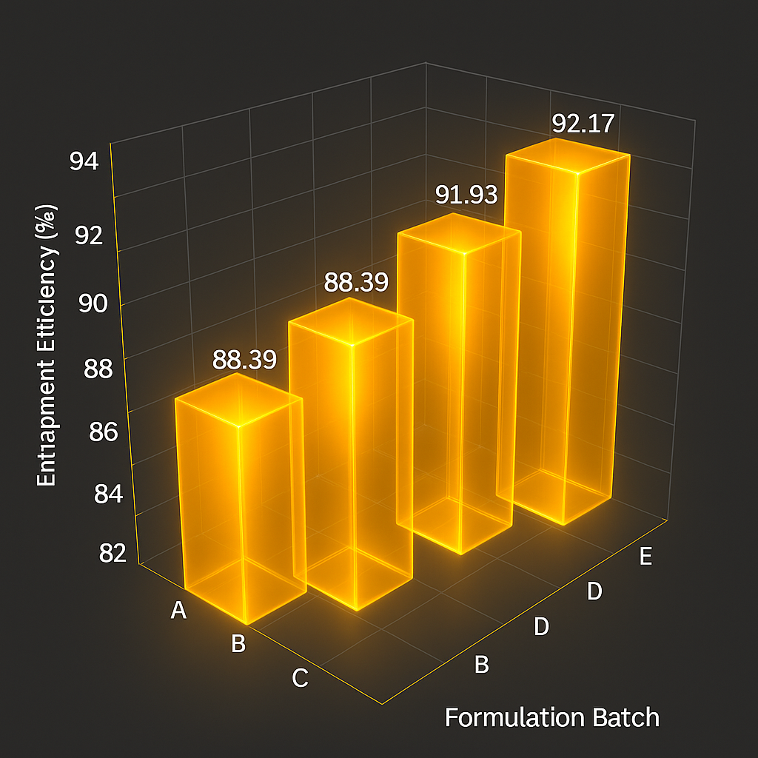

Figure 3.9: Bar Graph showing %EE of Formulations.

|  |  |  |  |  |
| --- | --- | --- | --- | --- |
|  |  |  |  |  |
|  |  |  |  |  |

**Chapter 4: Discussion**

**4.1. Effect of Thyme Oil Concentration on the Physicochemical Properties of Meropenem-Loaded NLCs**

The incorporation of thyme oil into NLC formulations was evaluated to determine its influence on physicochemical parameters. A discernible trend emerged in the dataset; wherein incremental augmentation of thyme oil concentration was concomitant with a proportional rise in particle size. The control formulation (MPM-NLC), lacking thyme oil, exhibited the smallest particle size (51.35 nm), whereas the highest thyme oil-loaded formulation (NLCMT240) demonstrated the largest particle size (88.73 nm). This increase may be ascribed to the elevated lipid content introduced by thyme oil inclusion, which likely facilitated greater vesicular growth. In contrast, the**polydispersity index**exhibited a non-linear trajectory in response to increasing thyme oil concentrations. Although all formulations showed PI values below 0.3, formulations such as MPM-TO-NLC200 (PI: 0.2021) and MPM-TO-NLC240 (PI: 0.1518) demonstrated enhanced uniformity compared to NLCMT240 (PI: 0.2518). This suggests that moderate concentrations of thyme oil may enhance lipid bilayer organisation and surfactant-lipid interaction, thereby facilitating more uniform particle formation. However, surpassing a critical concentration threshold appears to perturb the emulsification dynamics, likely due to lipid oversaturation, culminating in broader particle distributions. Regarding**zeta potential**, all formulations recorded values between –32.22 mV to –33.99 mV, indicative of strong electrostatic repulsion and colloidal stability. The control formulation exhibited a ZP of –32.53 mV, whereas thyme oil-enriched formulations showed marginally more negative values. This imply that the addition of thyme oil may enhance the surface charge density of NLCs, potentially due to the orientation of surface-active molecules or interaction between thyme oil constituents and ionic surfactants.

Collectively these findings suggest that thyme oil exerts a concentration-dependent modulatory effect on the physicochemical characteristics of meropenem-loaded nanostructured lipid carriers. While moderate incorporation optimizes particle uniformity and stability, higher concentrations may compromise size and distribution due to lipid overloading. These findings highlight the imperative of meticulously optimising essential oil concentrations in lipid-based nanocarriers to achieve a balance between size, homogeneity, and surface charge. These factors are crucial for targeted pulmonary delivery and sustained antimicrobial efficacy.

**4.2. Stability Evaluation of NLC Formulations**

The colloidal stability of the formulations was analysed by assessing changes in particle size, polydispersity index and zeta potential at two storage temperatures (20 °C and 37 °C) and durations (24 and 48 hours). These parameters exhibited formulation-dependent and time-dependent variations. These parameters are critical indicators of nanoparticle stability, colloidal behaviour, and suitability for drug delivery applications. Among all formulations, the**Blank NLCs**exhibited the smallest and most stable particle sizes, ranging from 45.50 nm (zero hour) to 50.45 nm after 48 hours at 37°C. This minimal increase in size suggests high colloidal stability in the absence of active pharmaceutical ingredients (APIs) or essential oils. In contrast, the**MERO-loaded formulations** (MPM-NLCs and MPM-TO-NLCs) showed larger particle sizes, likely due to the incorporation of meropenem and/or thyme oil, which may influence lipid matrix organization and interfacial tension.

The**MPM-TO-NLC180**and**MPM-TO-NLC240**formulations demonstrated the greatest growth in particle size over time and temperature. Specifically,**MPM-TO-NLC180**showed a rise from 70.63 nm to 111.3 nm at 20°C/48h, and up to 92.68 nm at 37°C/48h.**MPM-TO-NLC240**increased from 88.73 nm at zero hour to 125.5 nm at 37°C/48h, indicating a temperature- and time-dependent growth, possibly due to aggregation or Ostwald ripening phenomena. These findings suggest that higher thyme oil content (as in TH-NLC240) may promote greater core mobility and destabilization under physiological temperature.

Interestingly,**MPM-TO-NLC200**showed the most consistent particle size profile among all thyme oil-containing formulations, maintaining a narrow range from 72.42 nm to 74.98 nm over time and temperature. This indicates that this formulation may possess an optimal balance between lipid content, meropenem, and thyme oil, resulting in a more thermodynamically stable nanoparticle system. Zeta potential is a key indicator of electrostatic repulsion between particles and plays a crucial role in colloidal stability. All formulations, including Blank NLCs and drug-loaded NLCs, maintained zeta potential values in normal range.

**Blank NLCs**consistently showed high negative zeta potential, with values such as -35.75 mV at zero hour and up to -49.41 mV after 24 hours at 37°C. This strong electrostatic repulsion likely contributed to their minimal size increase and overall colloidal stability. Formulations containing meropenem and thyme oil, however, exhibited slightly less negative zeta potentials, especially under prolonged storage. For instance,**MPM-NLCs**showed a drop from -39.53 mV at 20°C/24h to -30.14 mV at 48h, indicating a potential reduction in surface charge stability over time. Similarly,**MPM-TO-NLC180**and**MPM-TO-NLC240**showed fluctuations but maintained overall values within the stable range, suggesting that while electrostatic repulsion may decrease slightly, it remains sufficient to prevent major aggregation. Interestingly,**MPM-TO-NLC220**maintained a relatively stable zeta potential around -32 to -37 mV across all time points and temperatures, showing potential as a robust formulation candidate with consistent surface charge properties. Among all tested formulations,**MPM-TO-NLC200**and**MPM-TO-NLC220**showed a favourable balance between particle size stability and surface charge, making them promising candidates for further development.

**4.3. Effect of Sonication Time on the Physiochemical Characteristics**

The sonication time plays a key role in determining the physicochemical characteristics of NLCs, including particle size, polydispersity index and zeta potential. In this study, an extension of sonication time from 3 minutes to 6 minutes consistently resulted in a significant reduction in particle size across all formulations. This can be attributed to the increased energy input and shear forces generated by prolonged ultrasonic cavitation, which enhances droplet disruption and promotes the formation of smaller and more uniform nanoparticles.

The**Blank NLC**formulation showed a pronounced reduction in size from 98.48 nm to 45.50 nm, indicating that even in the absence of active pharmaceutical ingredients, sonication efficiently decreases particle dimensions. Similarly, MPM-NLCexhibited a size reduction from 107.8 nm to 51.35 nm. All**Mero-Thyme co-loaded formulations** displayed consistent decreases in particle size, albeit to varying extents. **MPM-TO-NLC200**, for instance, showed the greatest size reduction (from 117.8 nm to 72.42 nm), suggesting a possible interaction between thyme oil concentration and sonication efficiency. This implies that both sonication and optimal thyme oil concentrations are critical.

Sonication also significantly improved the uniformity of particle distribution. All formulations exhibited a decline in PI upon 6-minute sonication, with the most notable improvement observed in Mero-Thyme220 (from 0.3952 to 0.1518), indicating a transition toward a more monodisperse system. Lower PI values enhance formulation stability and reproducibility.

The zeta potential values also shifted toward more negative side with prolonged sonication, reflecting enhanced surface charge stabilization. In particular, the Blank NLC formulation showed a marked shift from –26.88 mV to –35.75 mV, and MPM-NLC from –29.81 mV to –32.53 mV. This increase in electrostatic repulsion may contribute to improved colloidal stability by preventing particle aggregation. The consistency of ZP enhancement across thyme oil-loaded formulations further underscores the utility of extended sonication in optimizing surface charge characteristics, irrespective of the lipid matrix composition or active constituents.

These findings confirm that increasing sonication time enhances physicochemical parameters of NLCs. The improvements in size reduction, homogeneity, and surface charge stabilization are crucial for achieving efficient pulmonary delivery, muco-penetration, and prolonged systemic circulation. However, excessive sonication beyond optimal limits may risk thermal degradation or destabilization of sensitive bioactives; thus, 6-minute sonication appears to achieve an effective balance in this context.

**4.4. Lyophilization of Formulations**

The influence of lyophilisation and varying sucrose concentrations on the physicochemical characteristics of meropenem-loaded nanostructured lipid carriers (MPM-NLCs) and thyme oil-containing NLCs (MPM-TO-NLCs) was evaluated in terms of particle size, polydispersity index, and zeta potential. Lyophilisation resulted in a marked increase in size compared to the non-lyophilised formulation. The non-lyophilised MPM-NLCs showed the smallest particle size (51.35 nm), while the lyophilised counterparts exhibited significantly larger sizes, depending on the concentration of sucrose and the presence of thyme oil. Sucrose acted as a cryoprotectant, but its effect was variable and formulation dependent. For MPM-NLCs, increasing sucrose concentration from 7% to 10% led to a substantial rise in particle size (from 98.48 nm to 128.6 nm), indicating that higher sucrose levels may promote osmotic stress or aggregation during freeze-drying.

In **MPM-TO-NLCs180,** the increase in sucrose concentration resulted in a moderate rise in particle size from 86.53 nm at 7% to 108.1 nm at 10%, suggesting partial stabilization but still some agglomeration during lyophilisation. Interestingly, in MPM-TO-NLCs220, the trend was reversed; the particle size was larger at 7% sucrose (140.8 nm) than at 10% (112.6 nm). This may be due to formulation-specific interactions between thyme oil components and sucrose, possibly leading to enhanced cryoprotection at higher sucrose concentrations or differences in lipid matrix composition and thermal sensitivity. The polydispersity index (PDI) remained within acceptable ranges (<0.5) for all formulations but tended to increase upon lyophilisation. The lowest PDI was seen in the non-lyophilised MpM-NLCs (0.269), reflecting a uniform particle distribution. Lyophilisation introduced broader size distributions, particularly in MPM-NLCs with 7% sucrose (PDI = 0.4381) and MPM-TO-NLCs180 with 10% sucrose (PDI = 0.4378), likely due to partial aggregation during the freeze-drying process.

Zeta potential values indicated that all formulations carried a negative surface charge, promoting colloidal stability through electrostatic repulsion. The highest absolute ZP was observed in the non-lyophilised MPM-NLCs (-32.53 mV). Post-lyophilisation, a reduction in ZP was noted, particularly in MPM-NLCs at 7% sucrose (-27.00 mV), suggesting reduced surface charge density possibly due to sucrose surface adsorption. However, in the thyme oil-loaded formulations, the ZP values remained largely stable or even increased in magnitude (-32.29 mV for MPM-TO-NLCs180 at 10%), indicating that thyme oil might play a stabilizing role, preserving interparticle repulsion during freeze-drying.

The findings demonstrated that the cryoprotective effect of sucrose was formulation dependent. Increasing sucrose concentration from 7% to 10% in MPM-NLCs led to a marked rise in particle size (from 98.48 nm to 128.60 nm), indicating that higher sucrose levels did not necessarily enhance protection but may rather contribute to osmotic stress or aggregation. However, the incorporation of thyme oil modulated the lyophilisation response, resulting in comparatively smaller particle sizes and more stable zeta potential values. At 7% sucrose, MPM-TO-NLCs180 exhibited a reduced size (86.53 nm) and more negative zeta potential (−31.45 mV) than MPM-NLCs (98.48 nm, −27.00 mV), a trend that persisted at 10% sucrose. These results, thereby, suggest thyme oil’s dual role as both an antimicrobial agent and a formulation stabilizer. A study conducted by Zhang et al. (2016) demonstrated that lyophilisation of nanostructured lipid carriers (NLCs) without optimal cryoprotectant concentration resulted in a significant increase in particle size and polydispersity index. Particularly, when sucrose concentration exceeded 5%, a further growth in size was observed, attributed to osmotic imbalances and crystalline transitions, highlighting the formulation-dependent effects of cryoprotectants, which aligns with the present findings in MPM-NLCs and MPM-TO-NLCs.

**4.5. Encapsulation Efficiency of ME-NLCs and Thyme Loaded NLCs**

Encapsulation efficiency (%EE) was determined by quantifying the difference between the total amount of meropenem initially added to the nanostructured lipid carriers (ME-NLCs) and the amount of free drug in the aqueous phase following filtration. Free meropenem concentration was measured using a validated high-performance liquid chromatography method. By subtracting the free drug content from the total drug quantity, the encapsulation efficiency was calculated to be approximately 85.72%.

High encapsulation of meropenem within NLCs has been documented by previous studies, highlighting its compatibility with the lipid matrix. **Rajpoot et al. (2022)** reported an encapsulation efficiency of approximately **84%** for meropenem-loaded NLCs, which was ascribed to the drug’s effective entrapment within the lipidic core. This finding supports the current study’s results, reinforcing that NLCs provide a favourable carrier system for hydrophilic β-lactam antibiotics like meropenem, thereby enhancing their stability and therapeutic potential.

In addition to Rajpoot et al. (2022), a master's thesis by **Wilson et al. (2024)** provides confirmation of high encapsulation efficiency for meropenem-loaded NLC formulations to be of approximately**85.7%**, This aligns closely with Rajpoot et al.'s 84% EE, reinforcing the robustness and reproducibility of meropenem incorporation into NLCs.

**Chapter 5: Conclusion**

This study developed and characterized meropenem-loaded nanostructured lipid carriers (MPM-NLCs), with and without thyme oil, to enhance drug delivery efficacy and stability. The physicochemical properties of the NLCs were modulated by varying thyme oil concentrations, which led to a controlled increase in particle size while maintaining optimal polydispersity indices (PDI < 0.3) and stable zeta potential values (−30 mV to −35 mV), confirming colloidal stability.

Stability studies revealed that both temperature and time influenced particle characteristics, with higher temperatures and longer durations generally promoting particle growth. Among the thyme oil-containing formulations, MPM-TO-NLC200 and MPM-TO-NLC220 demonstrated superior stability, maintaining consistent particle size and surface charge across test conditions.

Lyophilisation studies further demonstrated that sucrose, as a cryoprotectant, effectively preserved formulation integrity; however, its optimal concentration varied by formulation. Thyme oil exhibited a stabilizing effect during freeze-drying, especially in combination with 10% sucrose, suggesting synergistic interactions between lipid matrix and essential oil components.

High encapsulation efficiencies (>85%) were achieved, with thyme oil-loaded formulations showing values exceeding 90%, supporting the suitability of the NLC system for meropenem delivery. The validated HPLC method (R² = 0.9971) confirmed analytical reliability for drug quantification. The integration of thyme oil into meropenem-loaded NLCs not only maintained physicochemical and colloidal stability but also enhanced formulation stability during storage.

**Chapter 6. Future Challenges and Directions**

Future investigations should be directed toward elucidating in vivo pharmacokinetic profiles, quantifying pulmonary deposition efficiency, and rigorously assessing long-term physicochemical stability under accelerated and real-time conditions, to holistically ascertain the translational viability and clinical applicability of this nanotherapeutic platform.

Though this study highlights the potential of meropenem-thyme oil-coloaded nanostructured lipid carriers as an antimicrobial strategy against Pseudomonas aeruginosa in cystic fibrosis (CF), several challenges and critical research gaps remain. The present study is limited to in vitro physicochemical elucidation and stability assessments. Therefore, future research should prioritize in vivo paradigms to evaluate the pharmacokinetics, biodistribution, muco-penetration, and therapeutic efficacy. Moreover, the dynamicinterplay between NLCs, viscous mucus, and the complex biofilm matrix demands deeper exploration to ensure site-specific and sustained drug release. Correspondingly, advanced imaging techniques such as scanning and transmission electron microscopy (SEM/TEM) should be employed to visually elucidate nanoparticle–bacteria interactions.

Long-term stability remains an important area requiring further research. Given the viscousnature of CF mucus, future formulations should incorporate surface modifications or functional ligands to improve muco-penetration, enhance retention within pulmonary tissues and penetration into biofilm-embeddedbacteria. Future research should also address potential long-term pulmonary toxicity, and the immunological impact of repeated inhalation. Aerosolized NLC formulations must also be evaluated for their aerodynamic properties, deposition dynamics, and potential immunological footprints on lung tissues.